**SQL QUERY Using SqlBolt**

**Lesson :1**

**1.) Find the title of each film**

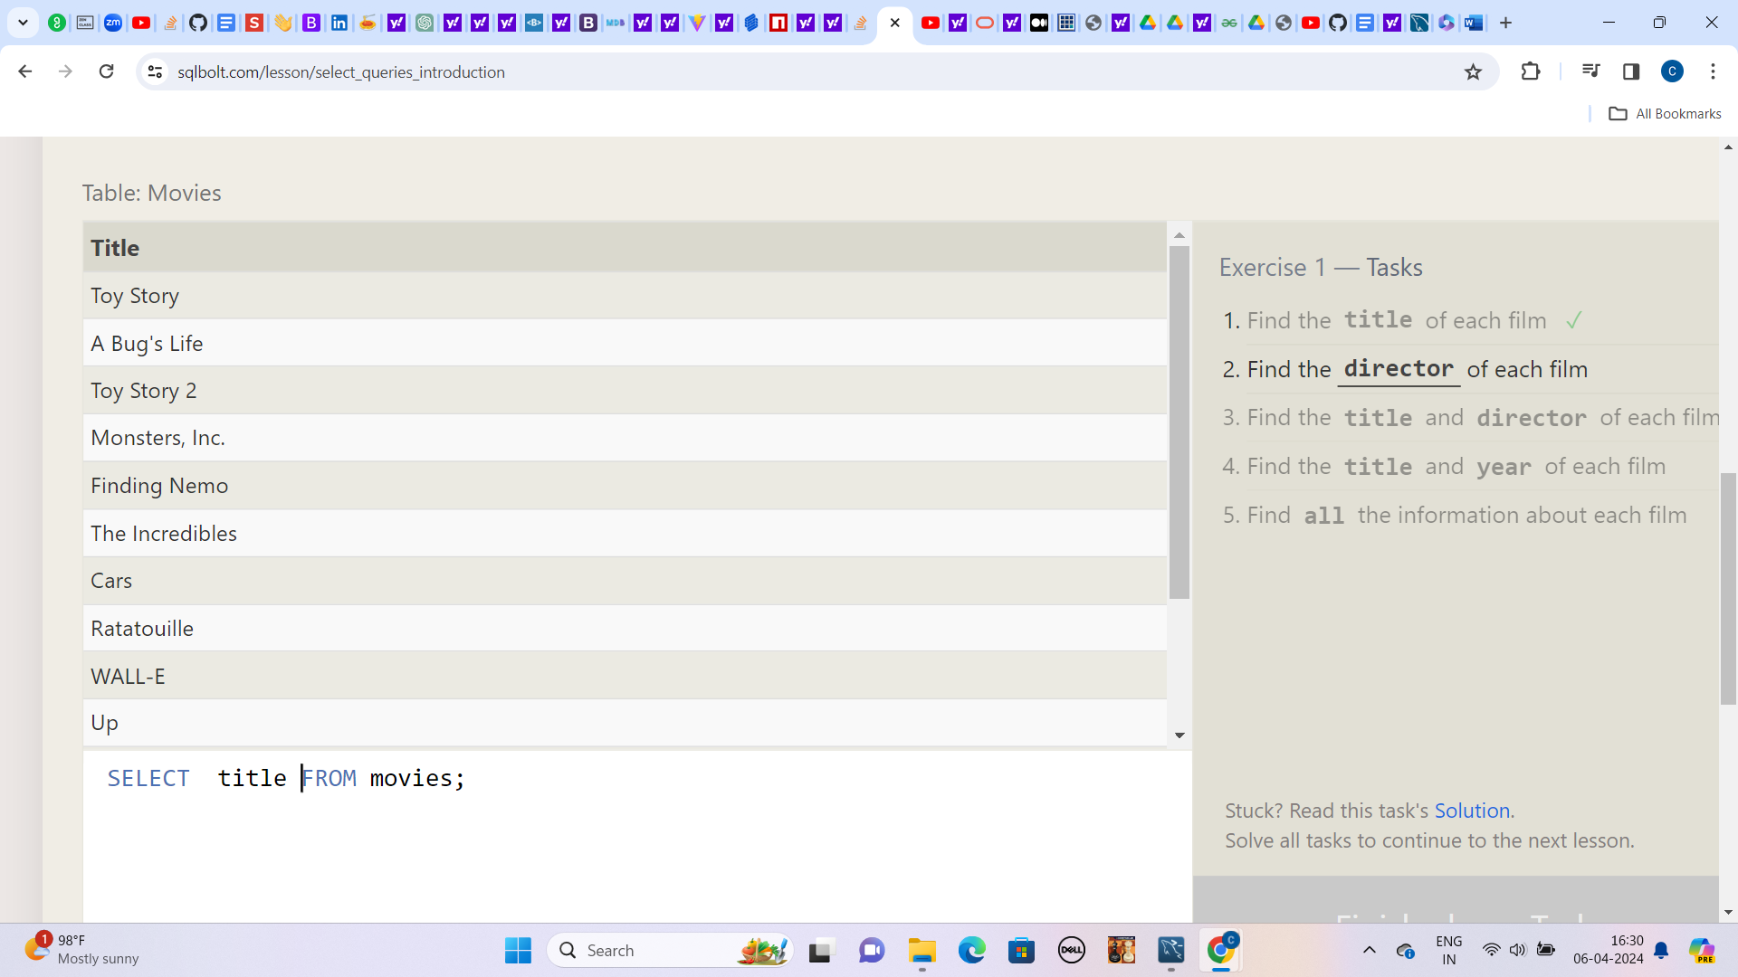

**2.)Find the director of each film**

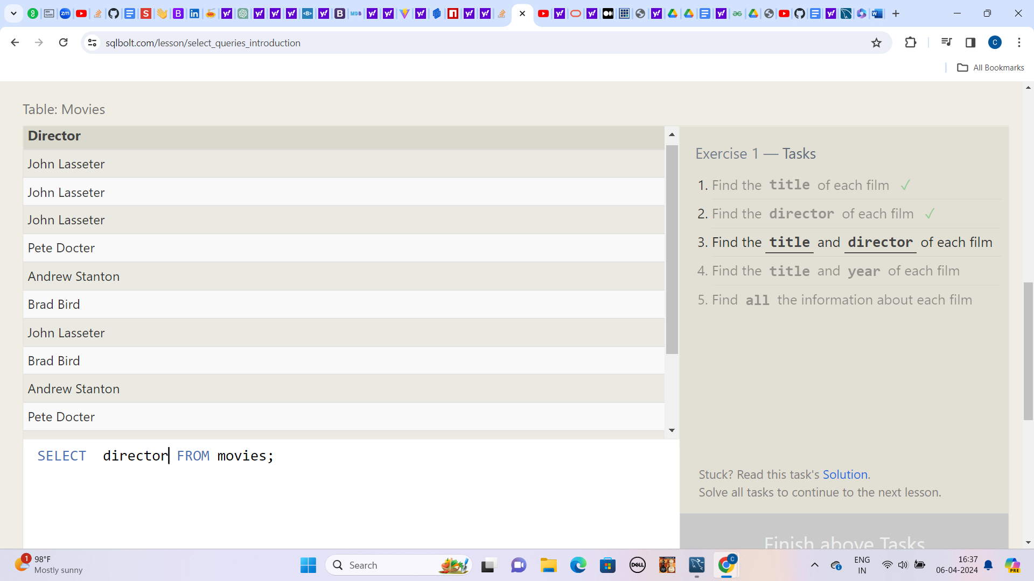

**3.) Find the title and director of each film**

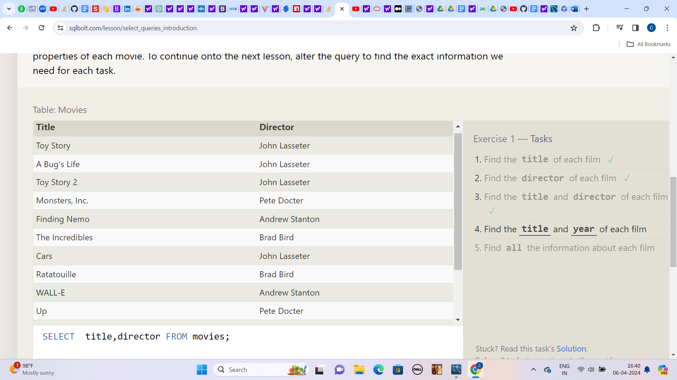

**4.) Find the title and year of each film**

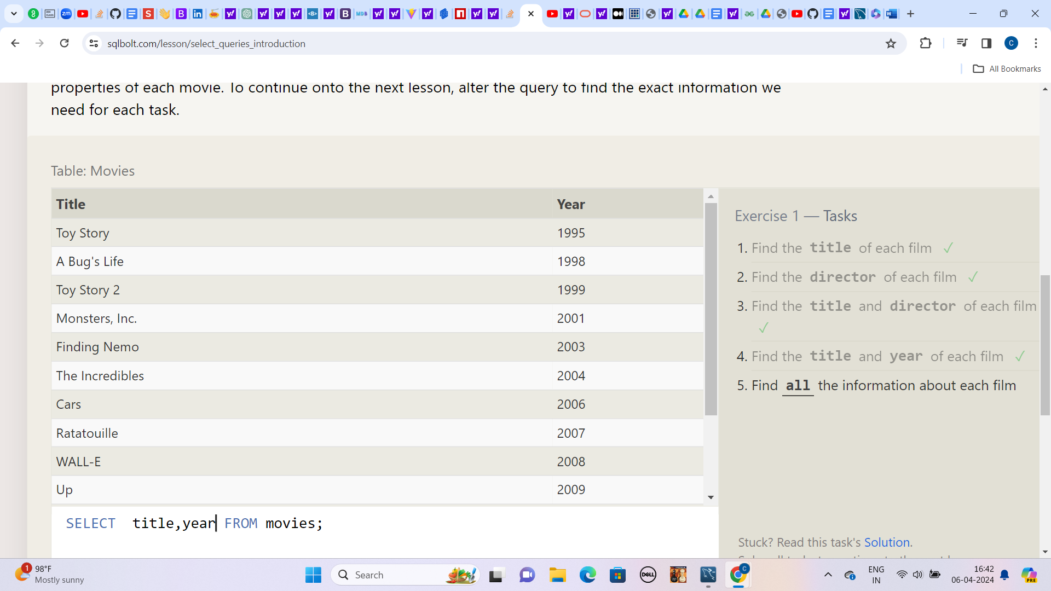

**5.) Find all the information about each film**

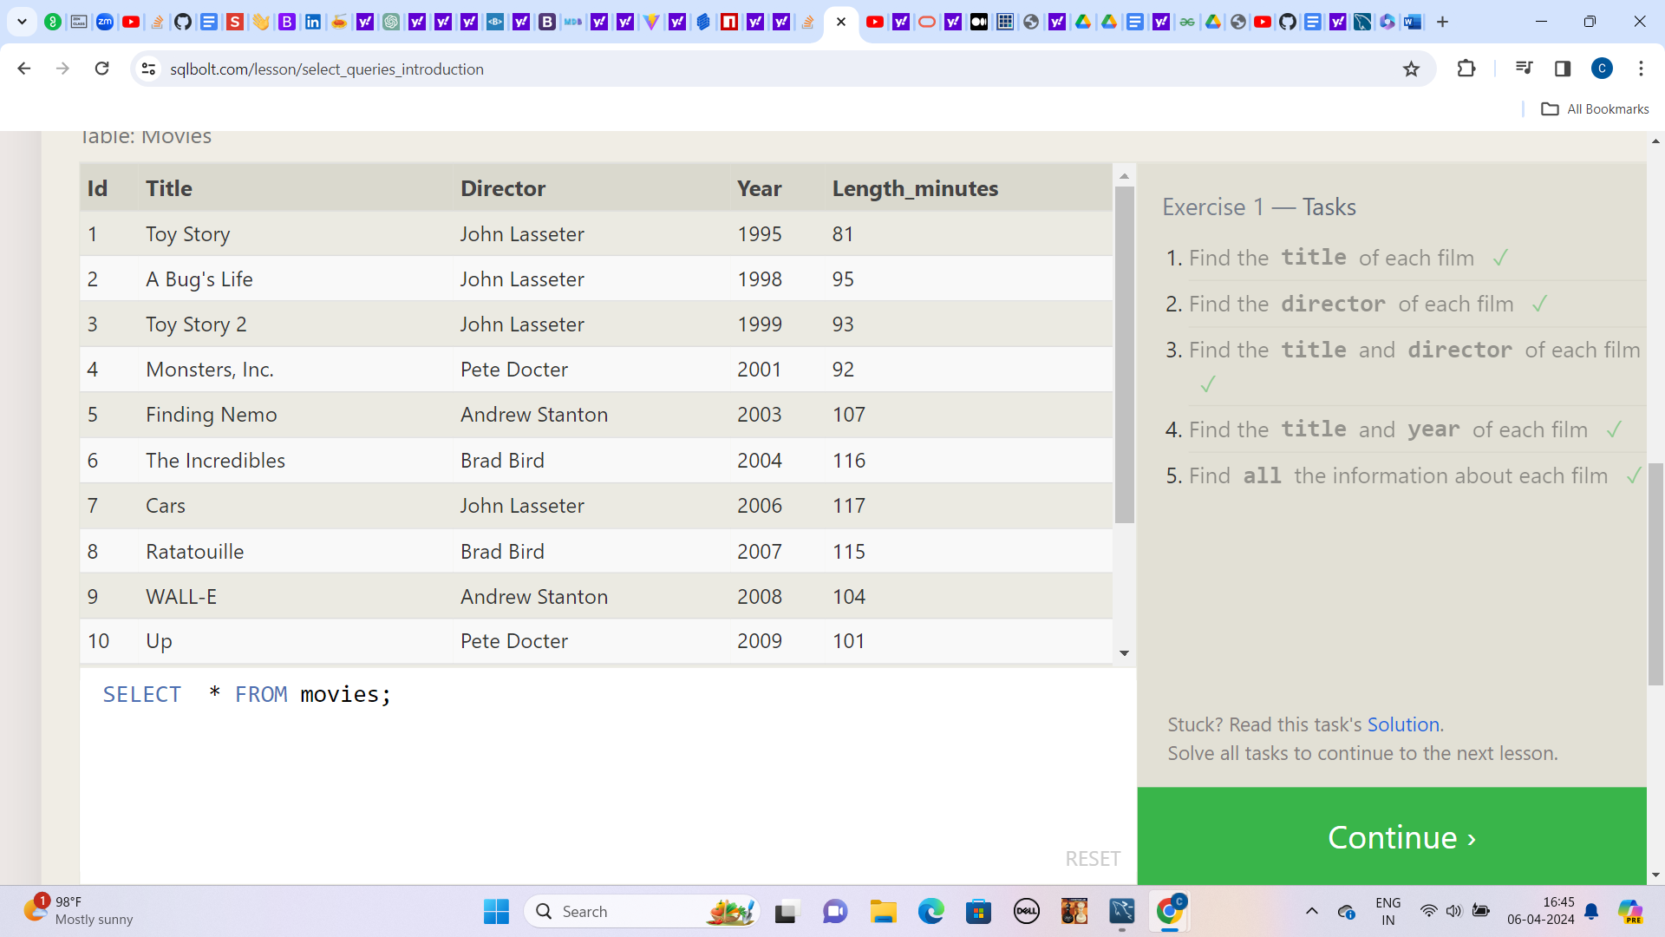

**Lesson:2**

**1.) Find the movie with a row id of 6**

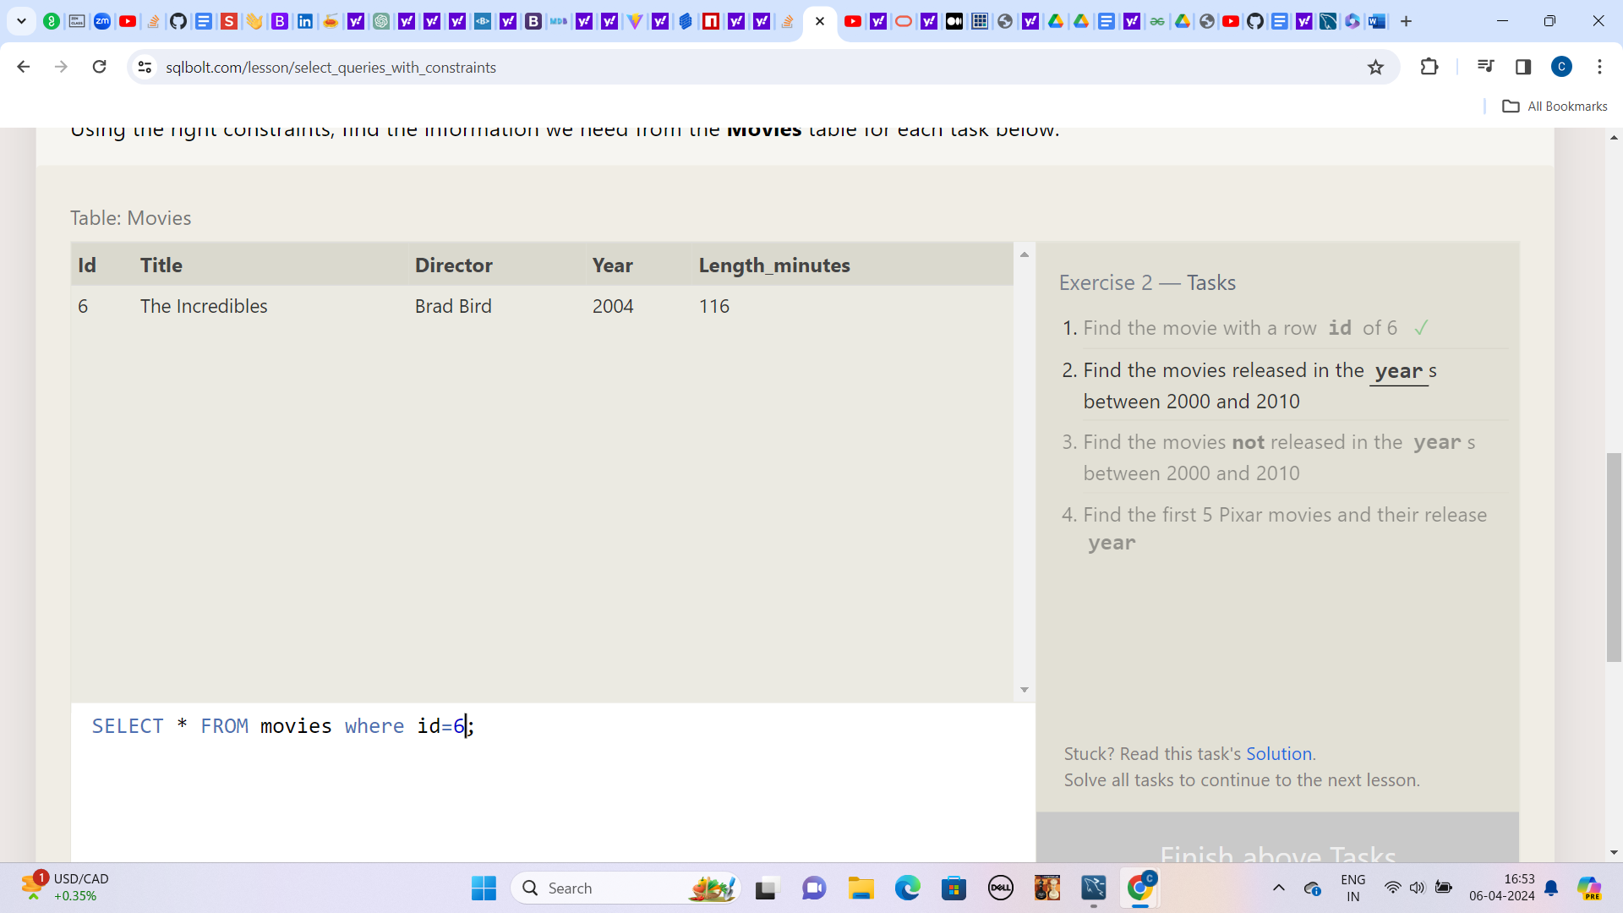

**2.) Find the movies released in the years between 2000 and 2010**

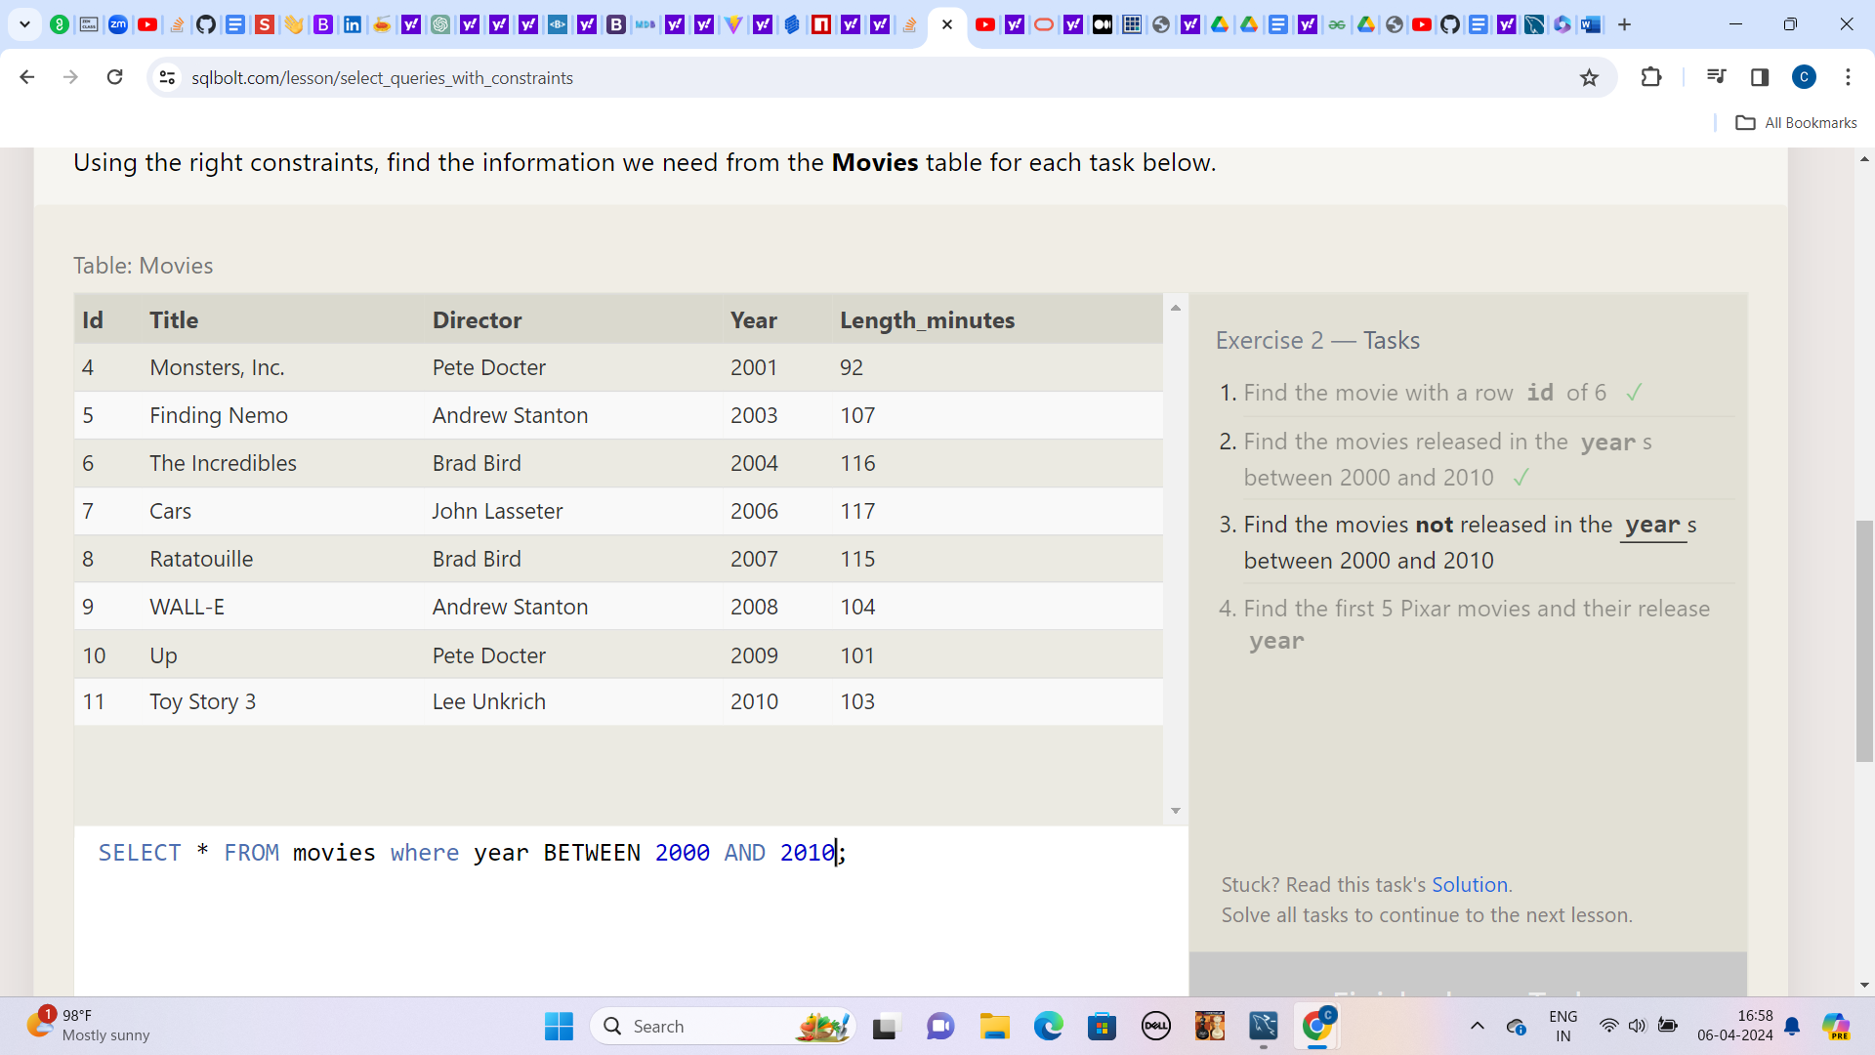

**3.) Find the movies not released in the years between 2000 and 2010**

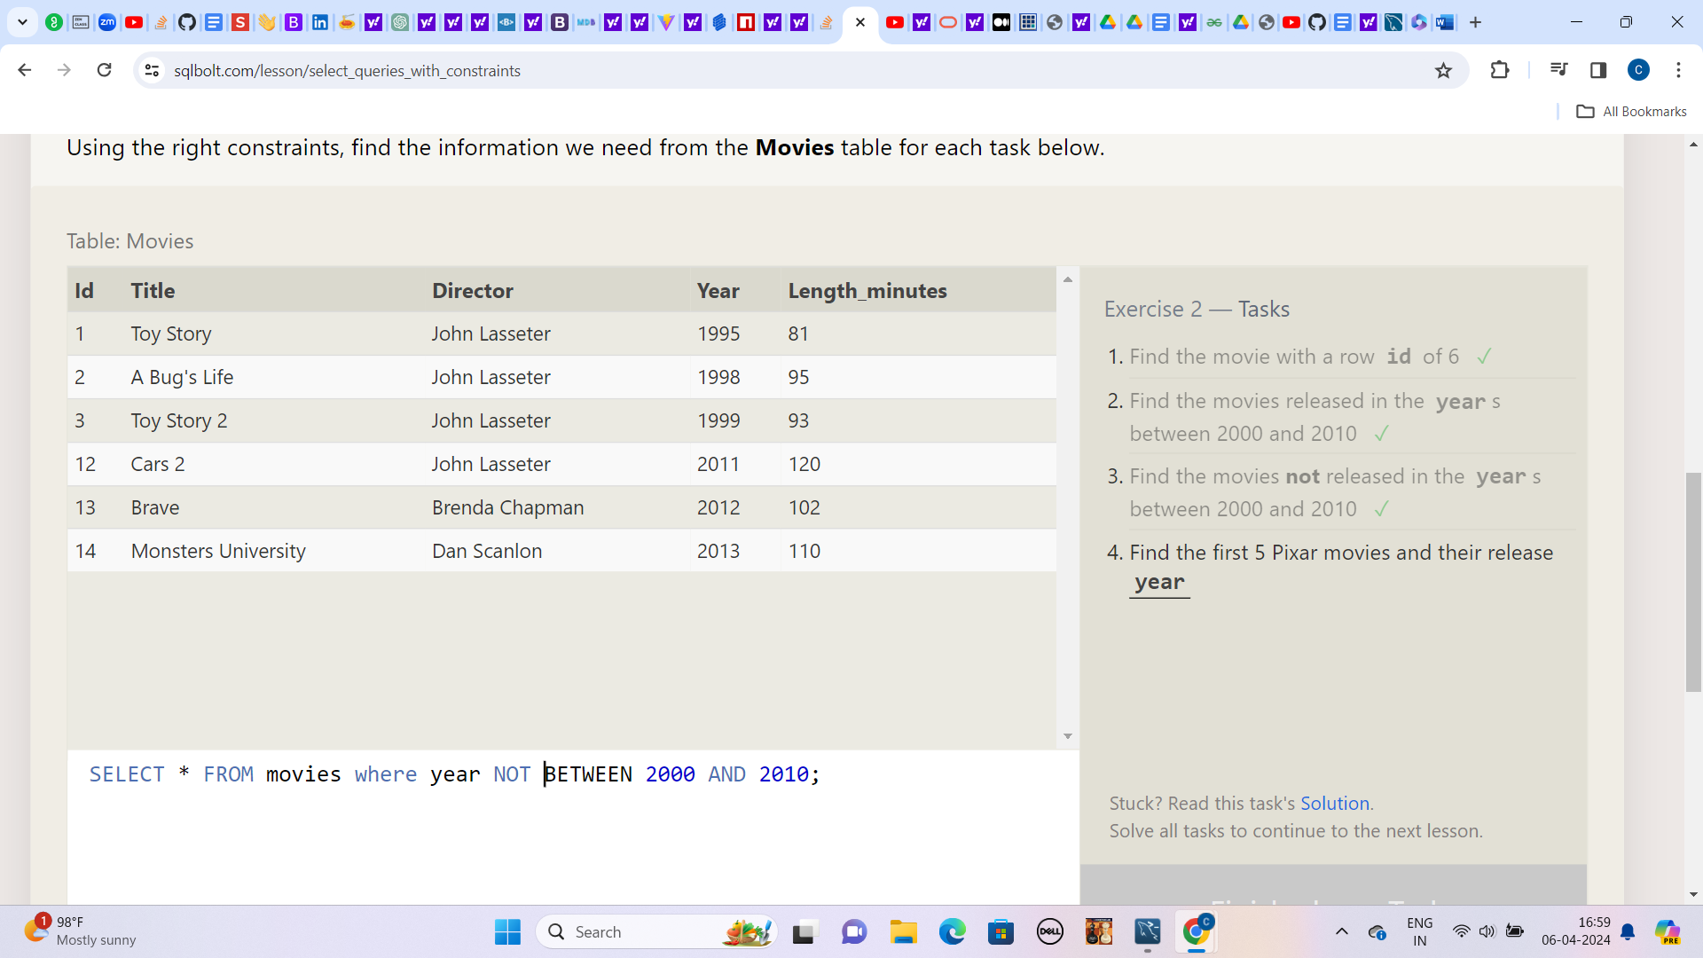

**4.) Find the first 5 Pixar movies and their release year**

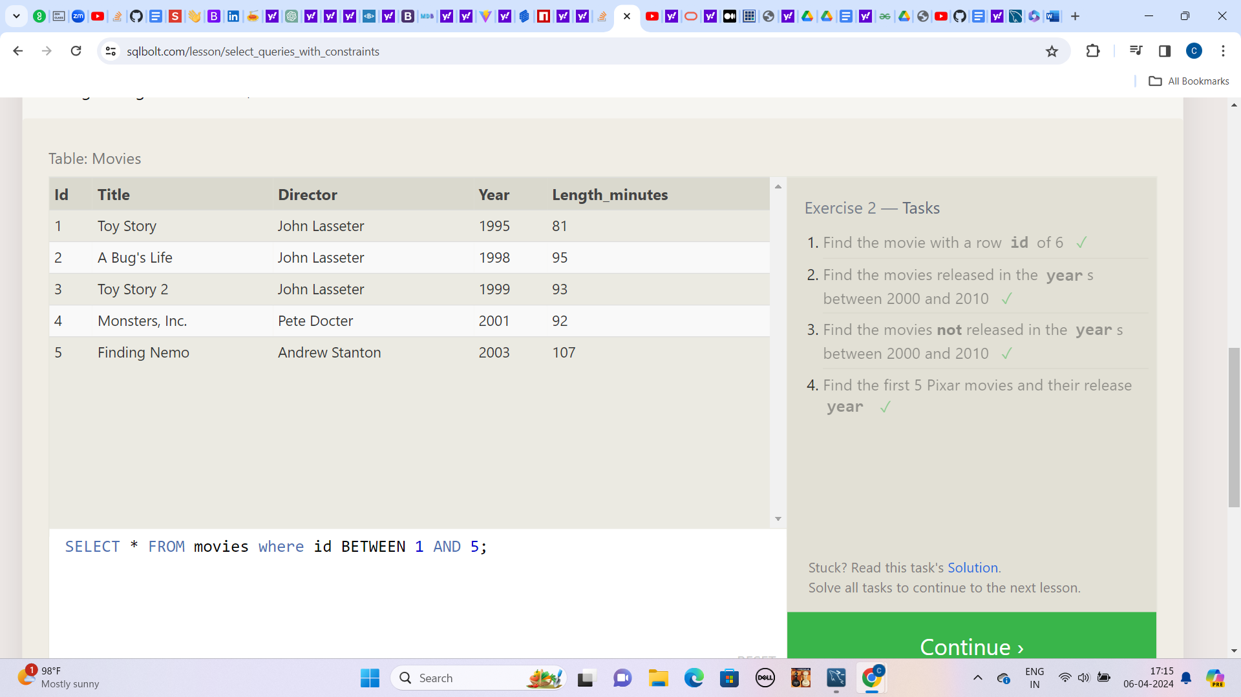

**Lesson:3**

**1.) Find all the Toy Story movies**

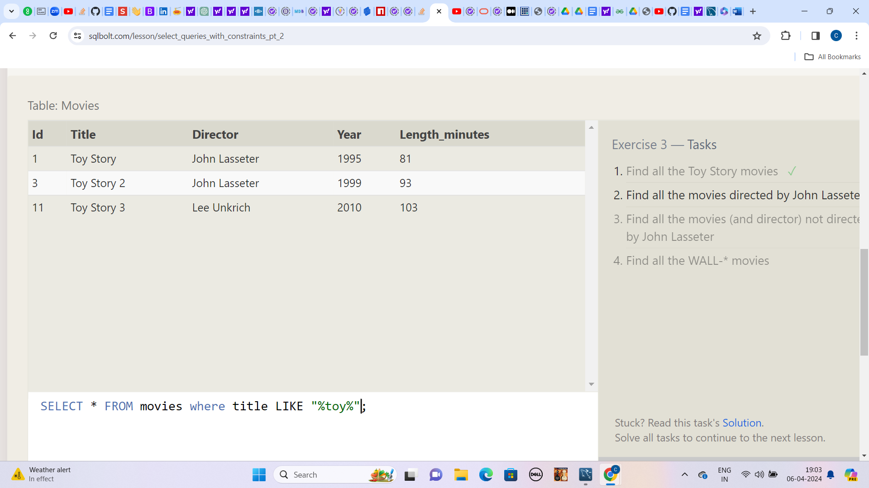

**2.) Find all the movies directed by John Lasseter**

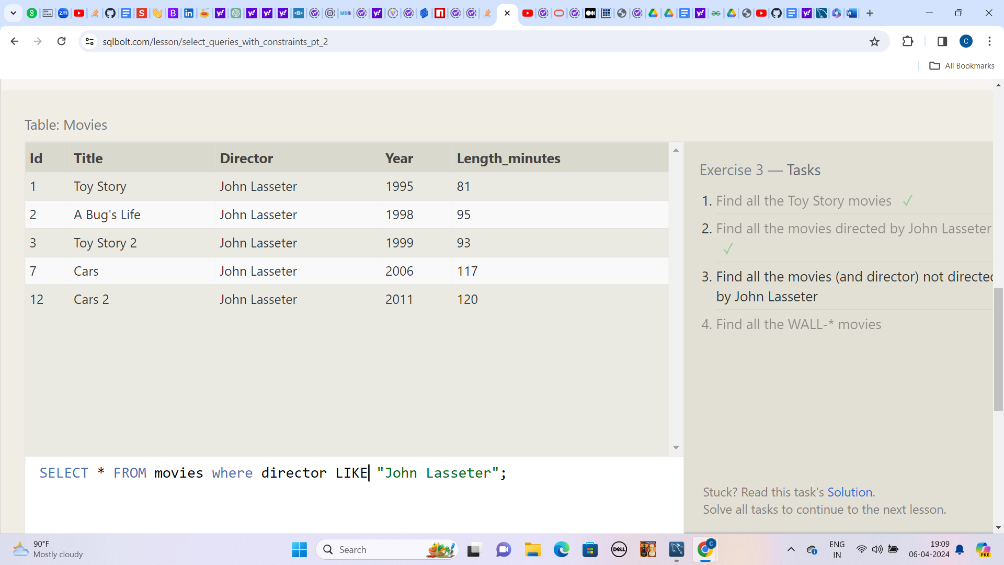

**3.) Find all the movies (and director) not directed by John Lasseter**

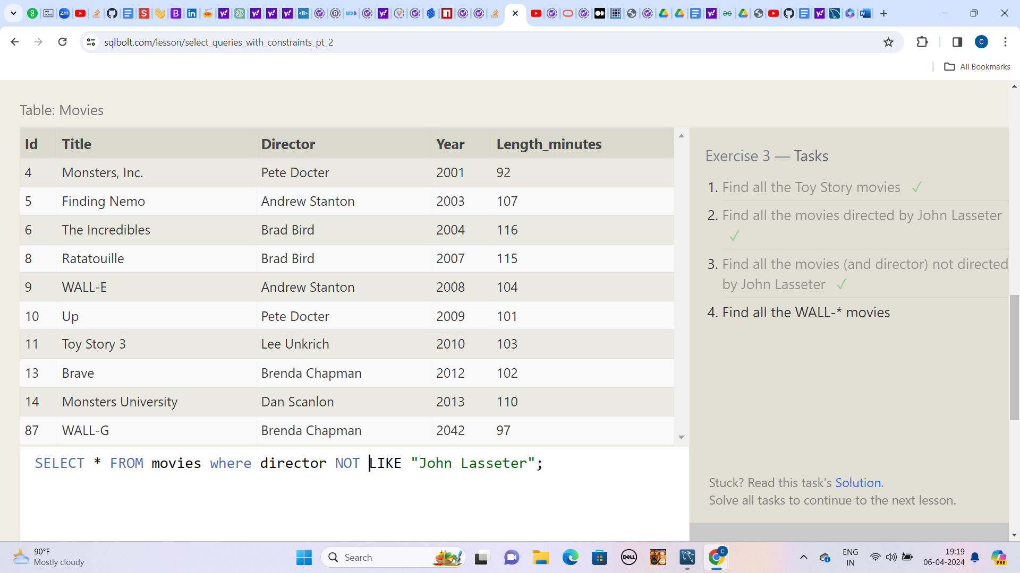

**5.) Find all the WALL-* movies**

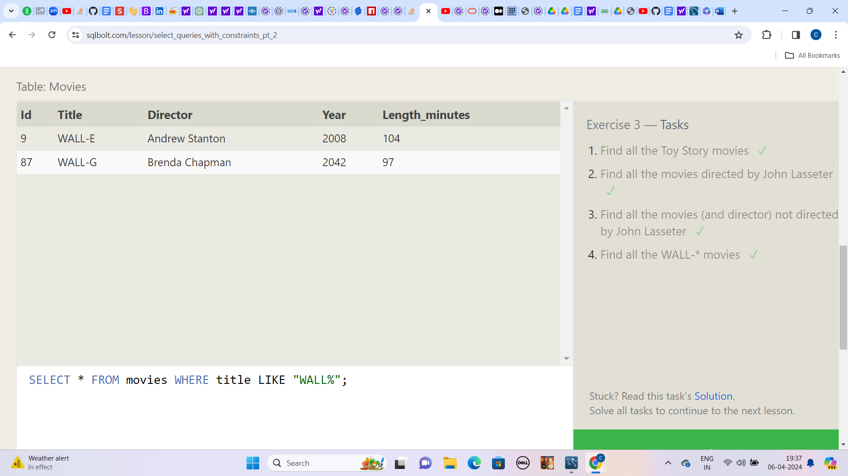

**Lesson: 4**

**1.) List all directors of Pixar movies (alphabetically), without duplicates**

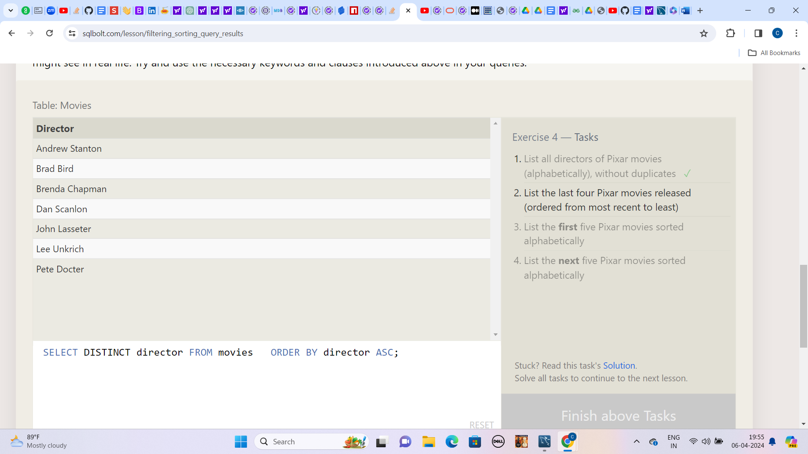

**2.) List the last four Pixar movies released (ordered from most recent to least)**

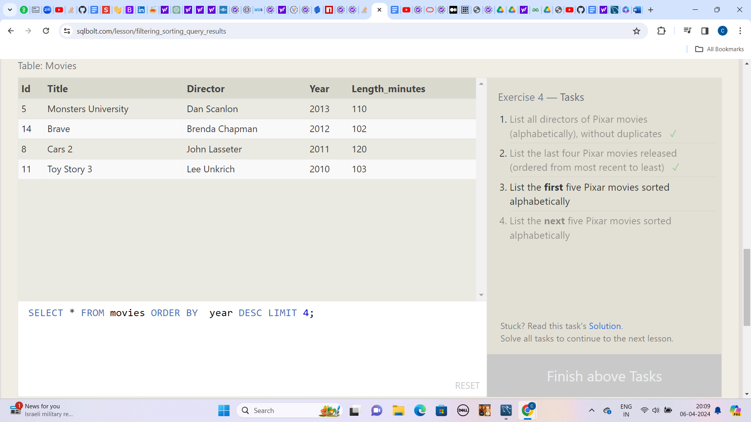

**3.) List the first five Pixar movies sorted alphabetically**

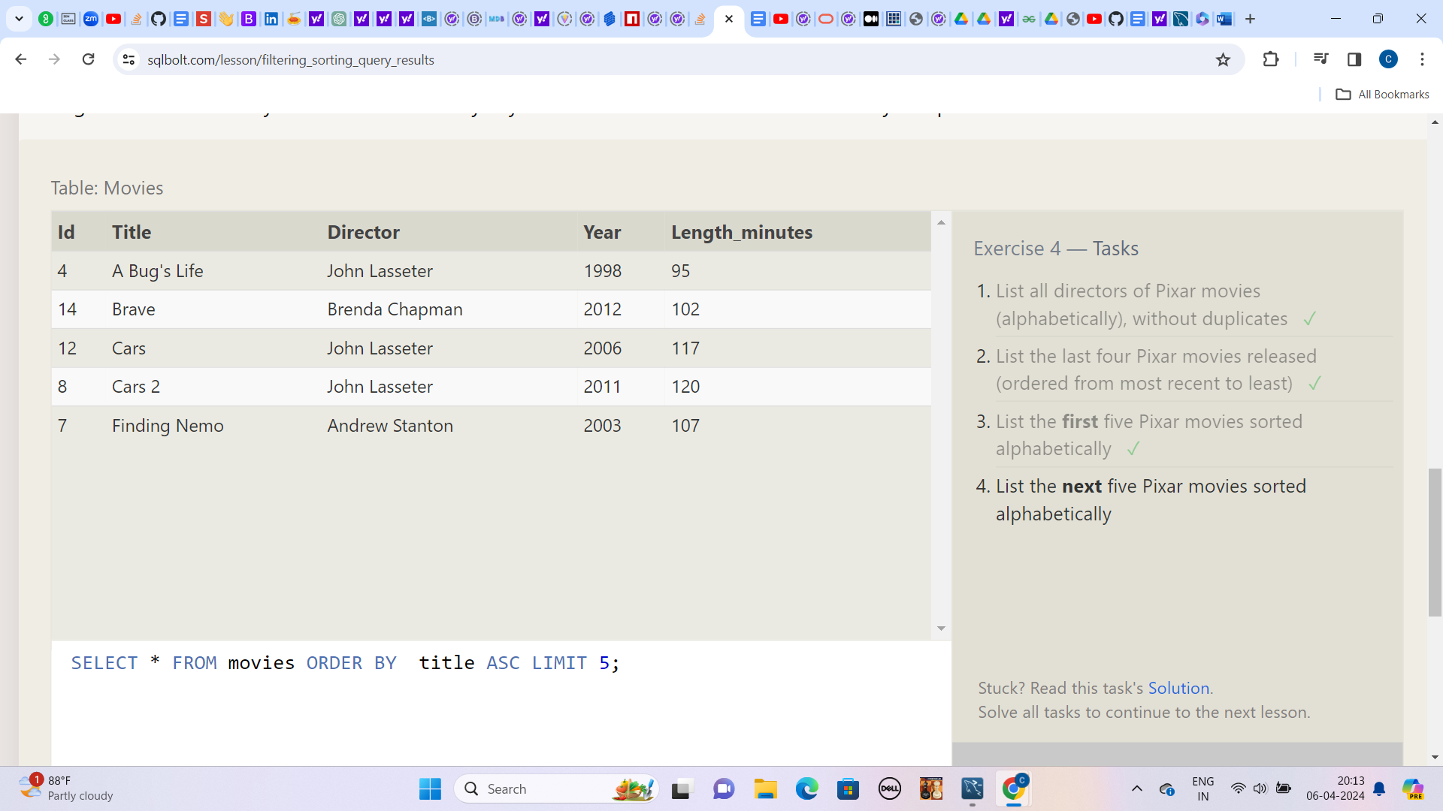

**4.) List the next five Pixar movies sorted alphabetically**

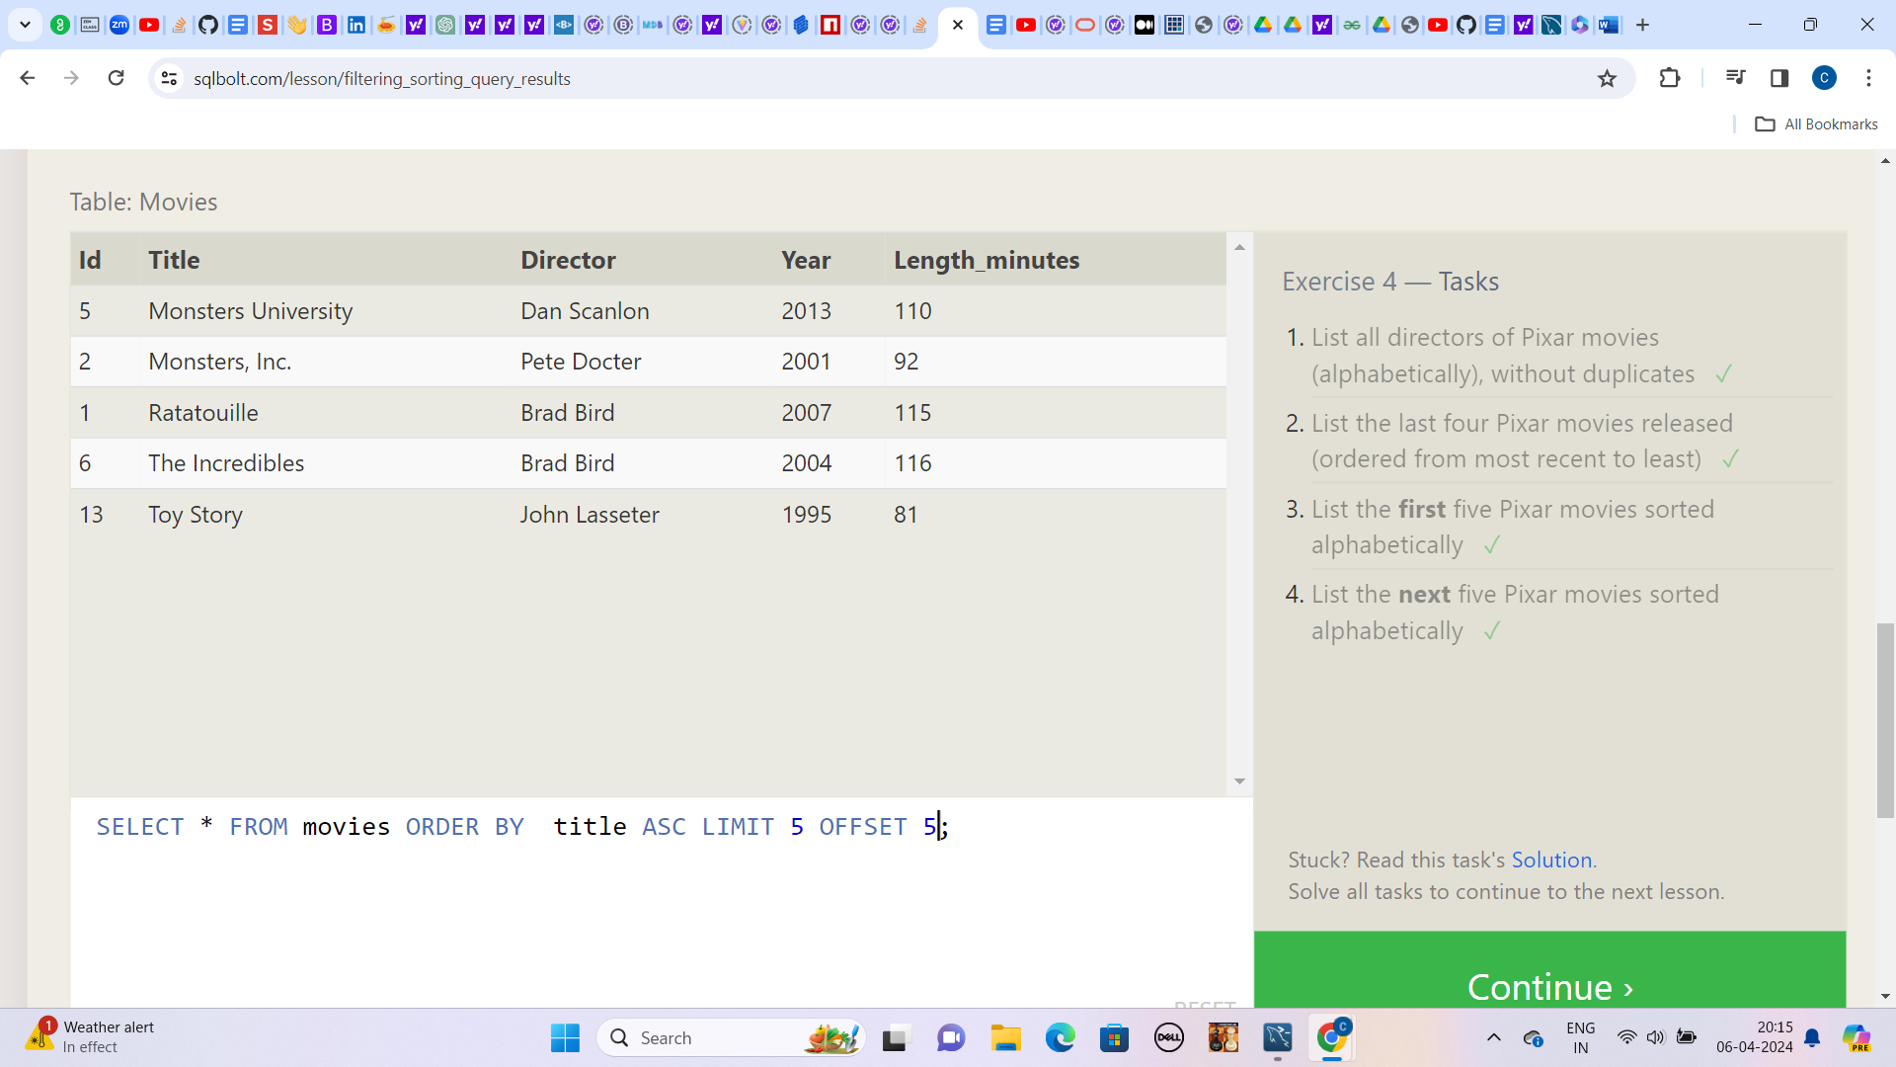

**Lesson:5**

**1.) List all the Canadian cities and their populations**

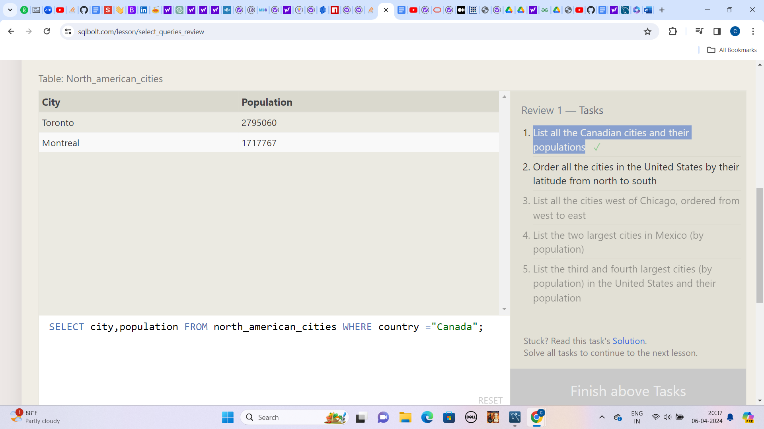

**2.) Order all the cities in the United States by their latitude from north to south**

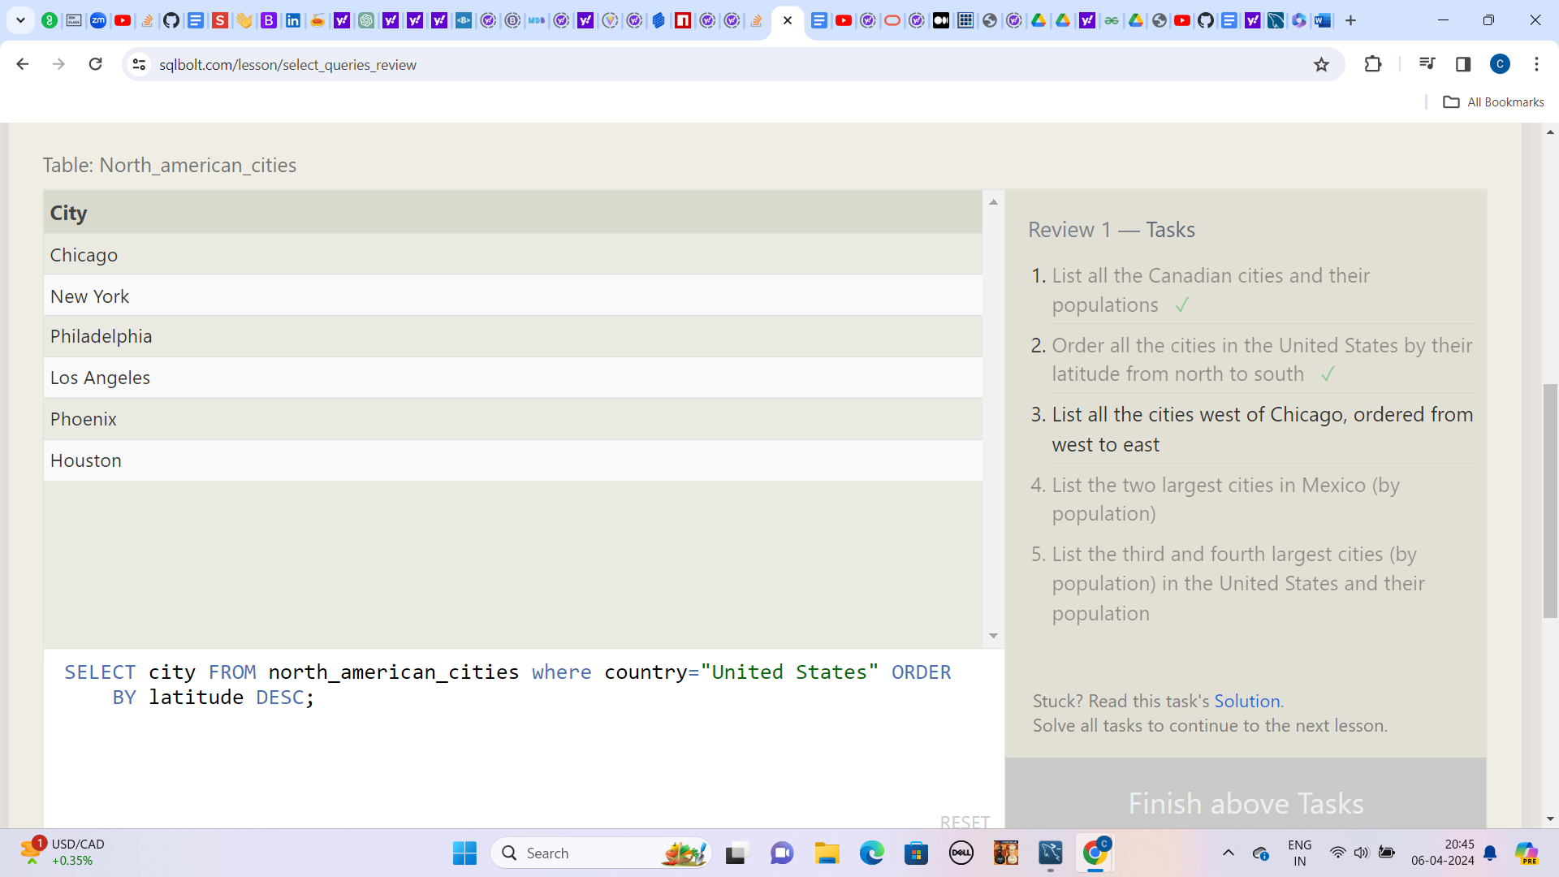

**3.) List all the cities west of Chicago, ordered from west to east**

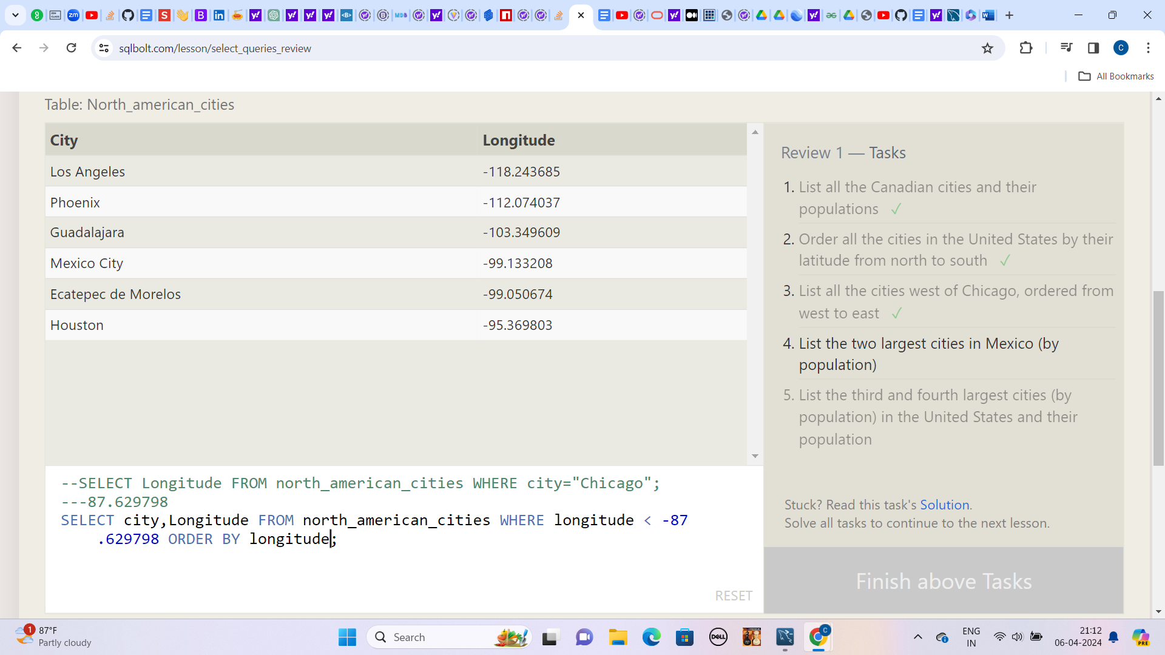

**4.) List the two largest cities in Mexico (by population)**

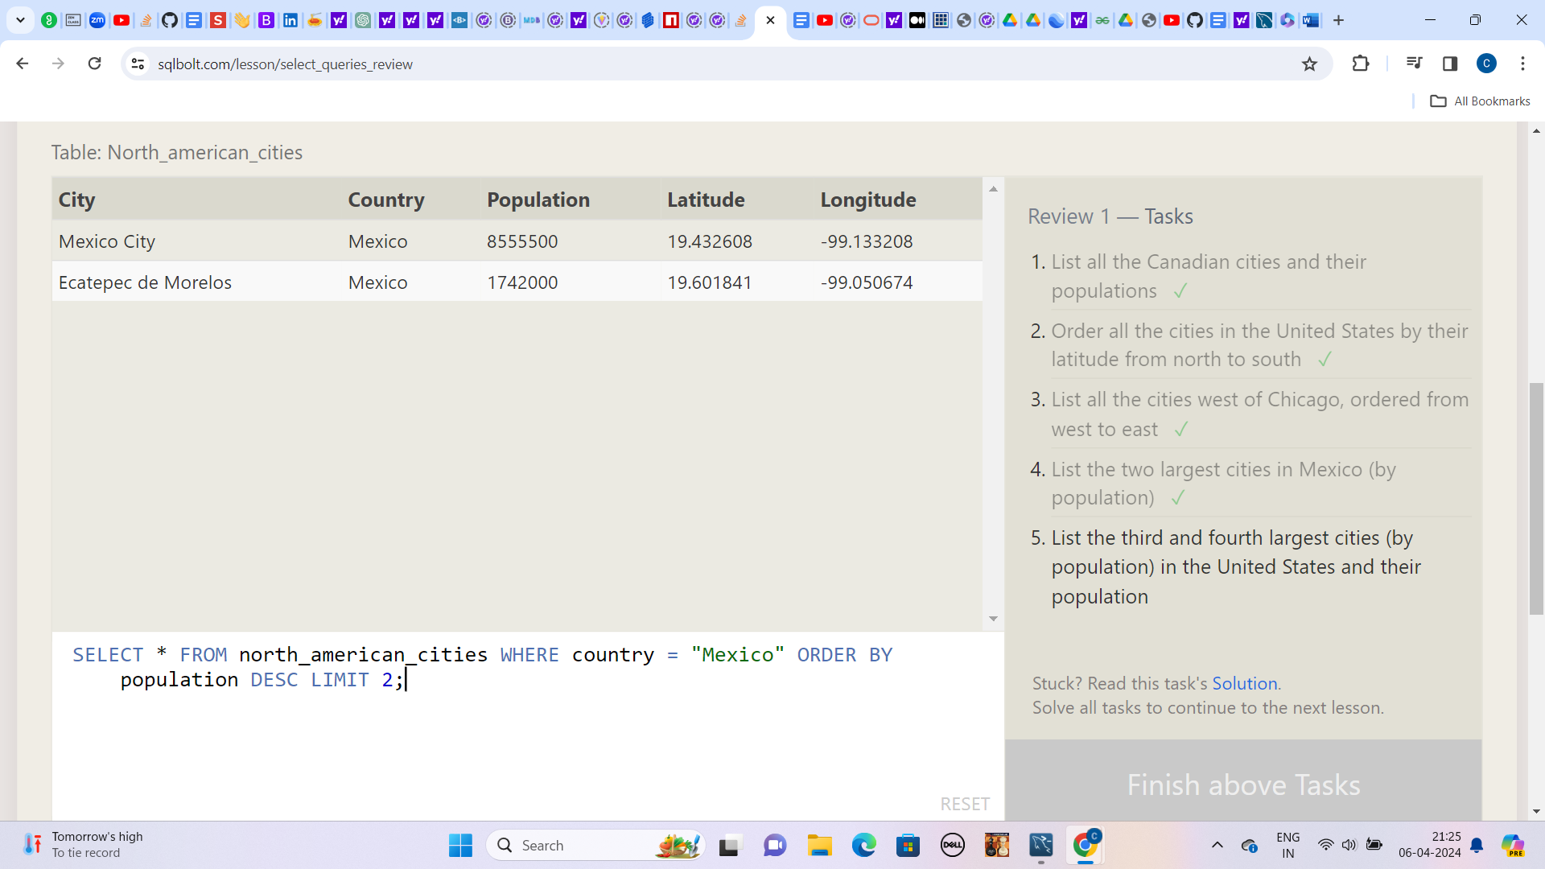

**5.) List the third and fourth largest cities (by population) in the United States and their population**

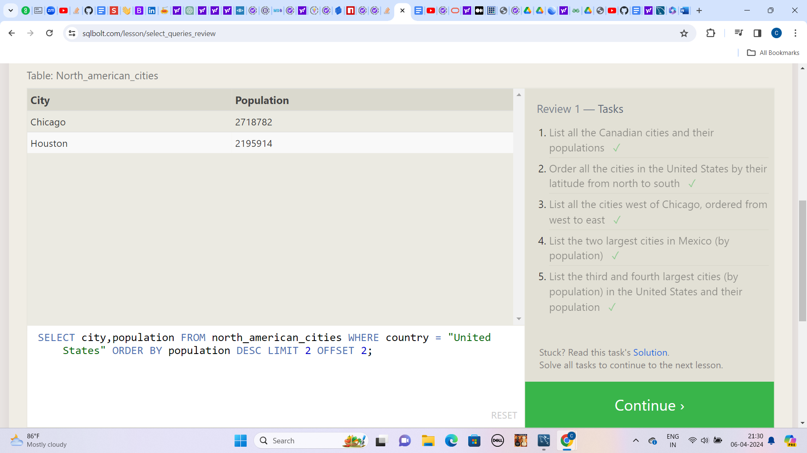

**Lesson: 6**

**1.) Find the domestic and international sales for each movie**

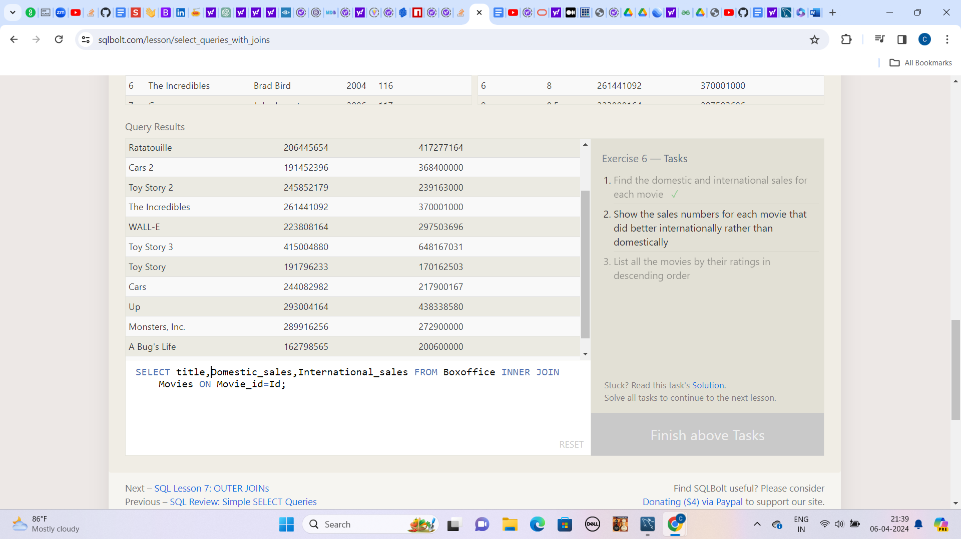

**2.) Show the sales numbers for each movie that did better internationally rather than domestically**

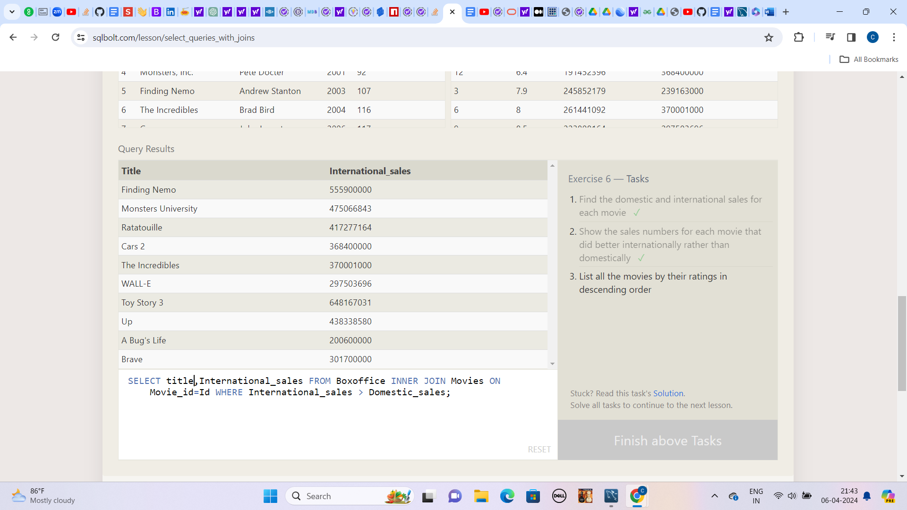

**3.) List all the movies by their ratings in descending order**

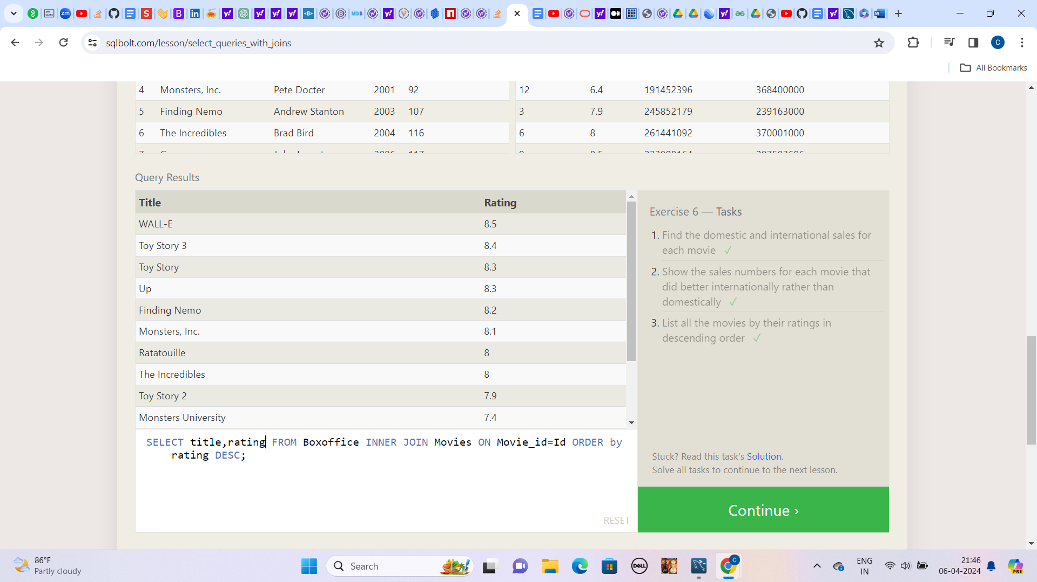

**Lesson:7**

**1.) Find the list of all buildings that have employees**

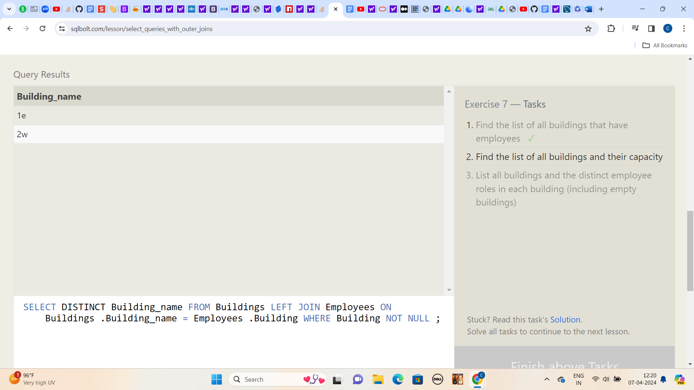

**2.) Find the list of all buildings and their capacity**

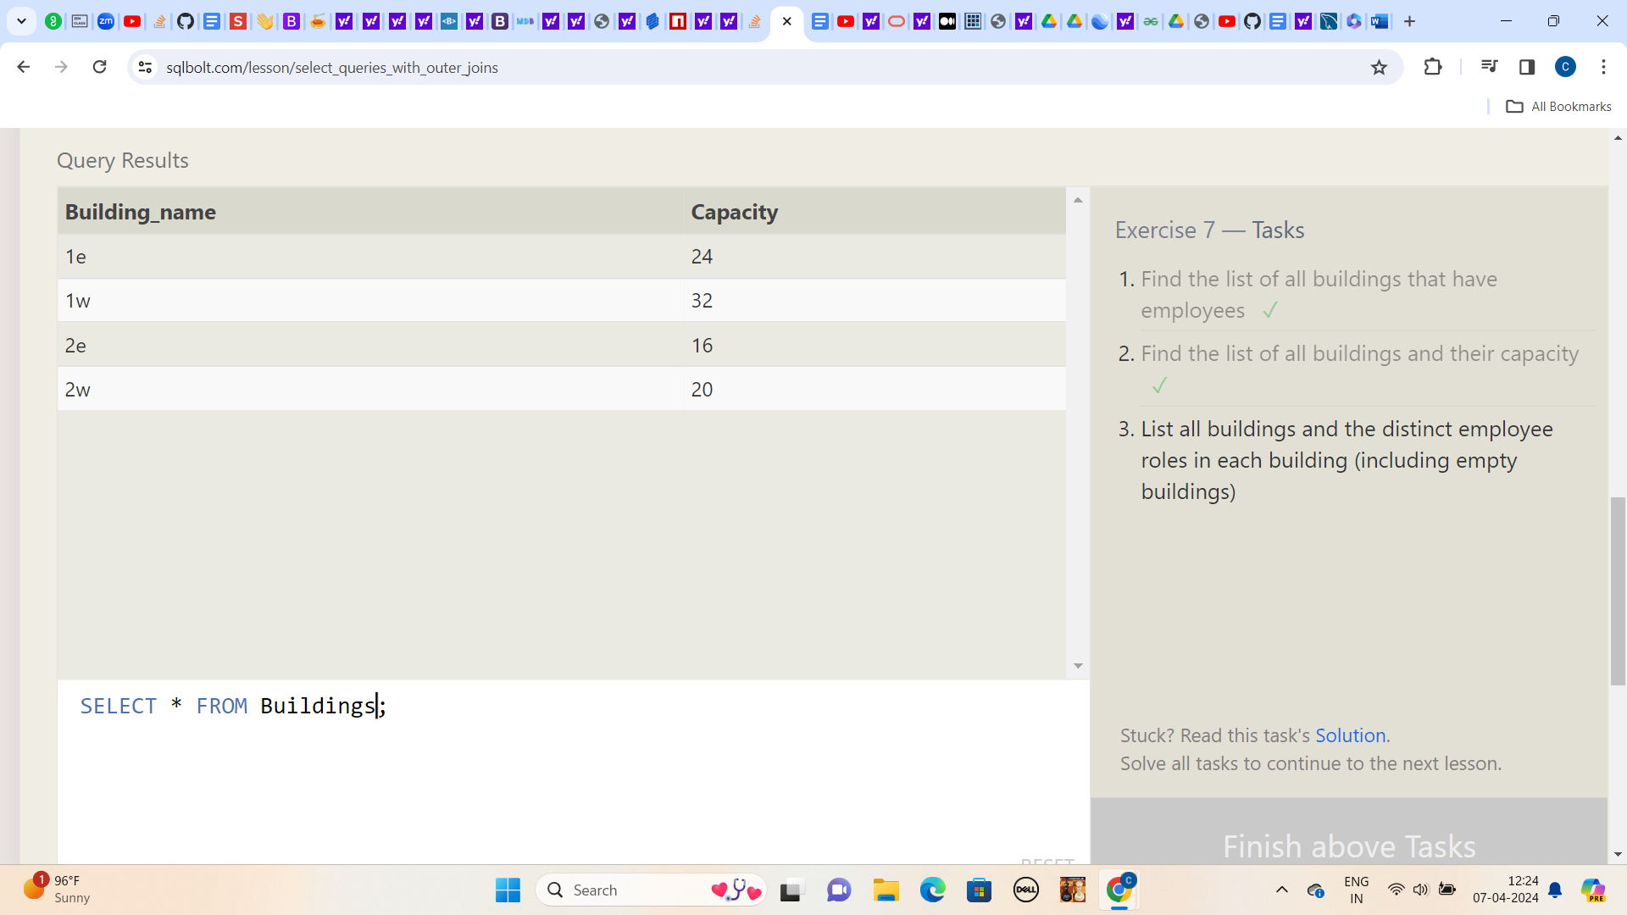

**3.) List all buildings and the distinct employee roles in each building (including empty buildings)**

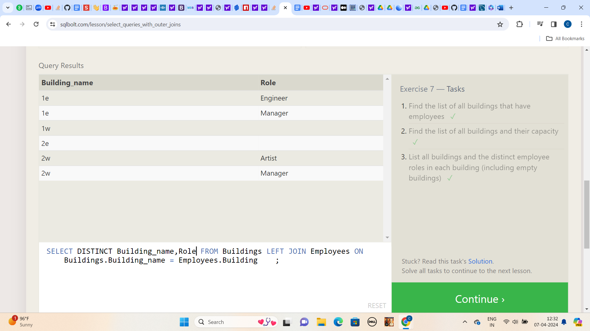

**Lesson:8**

**Find the name and role of all employees who have not been assigned to a building**

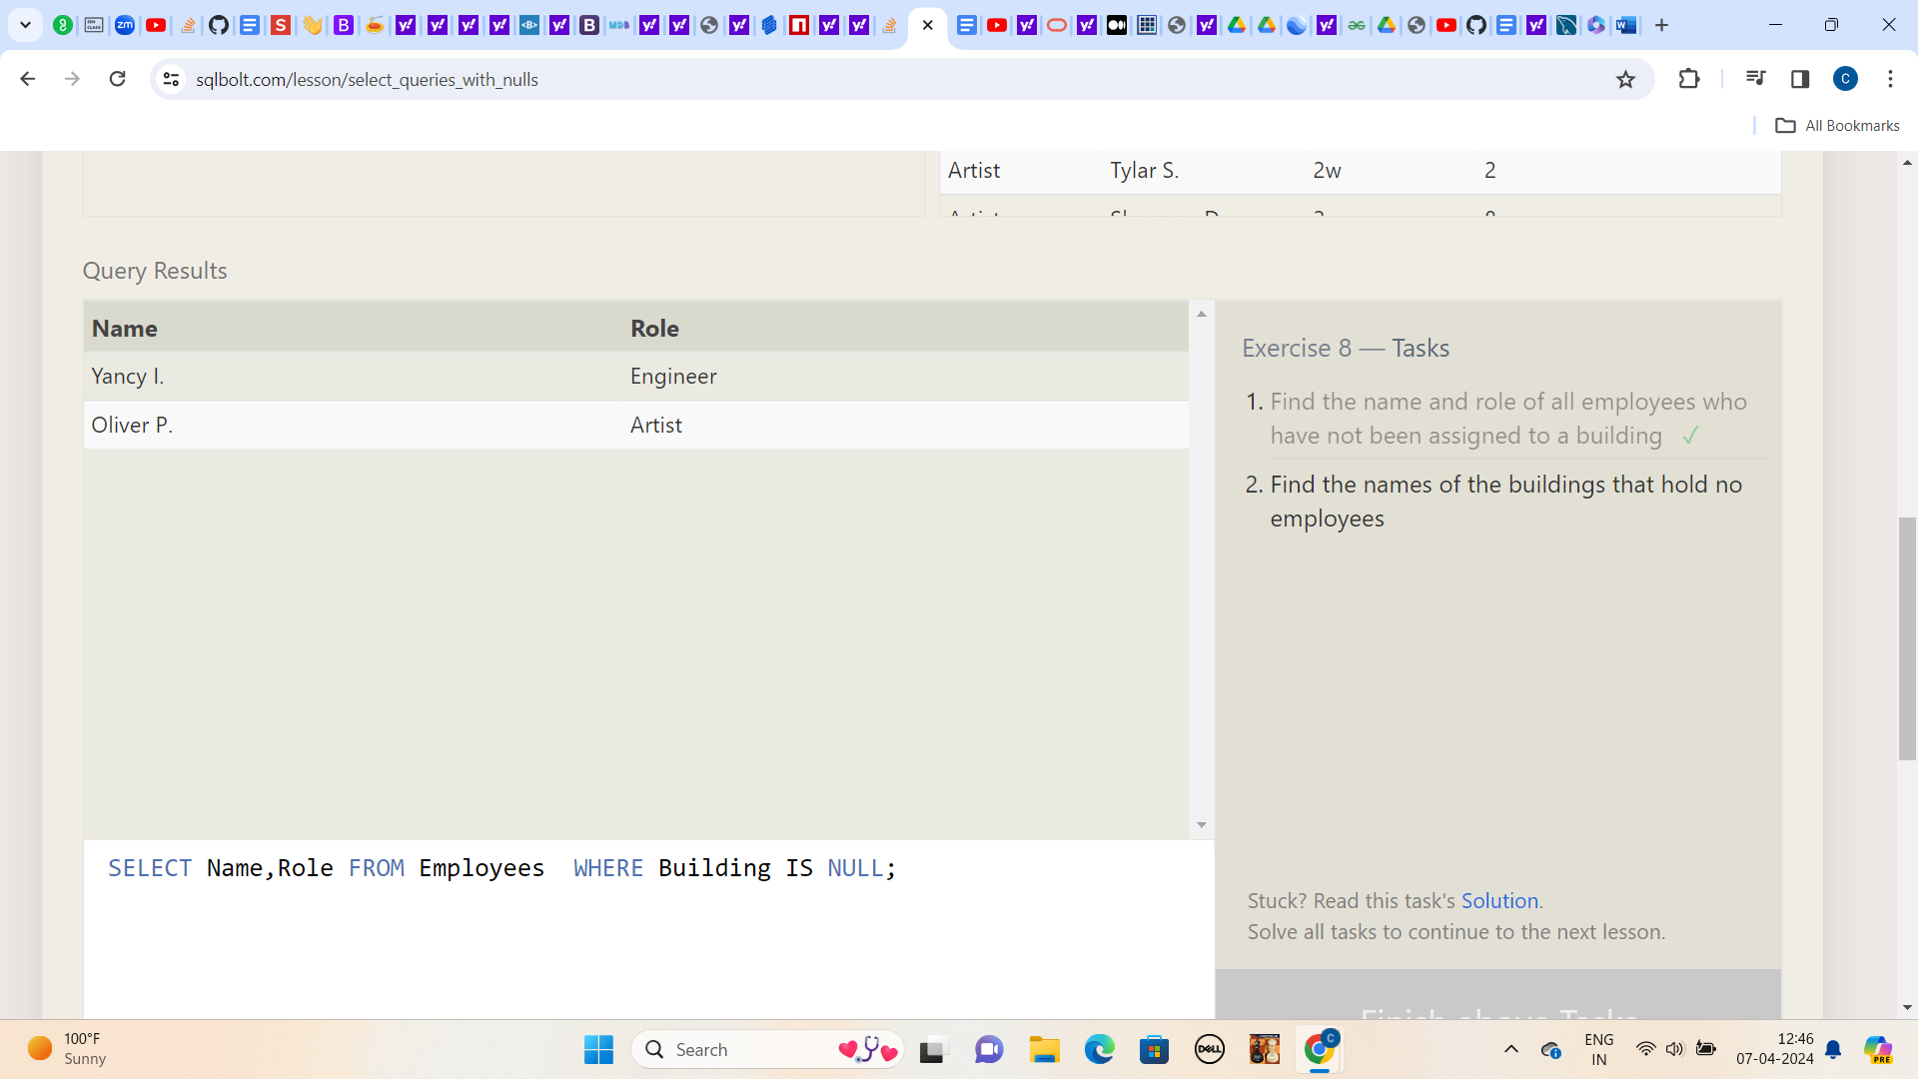

**2.) Find the names of the buildings that hold no employees**

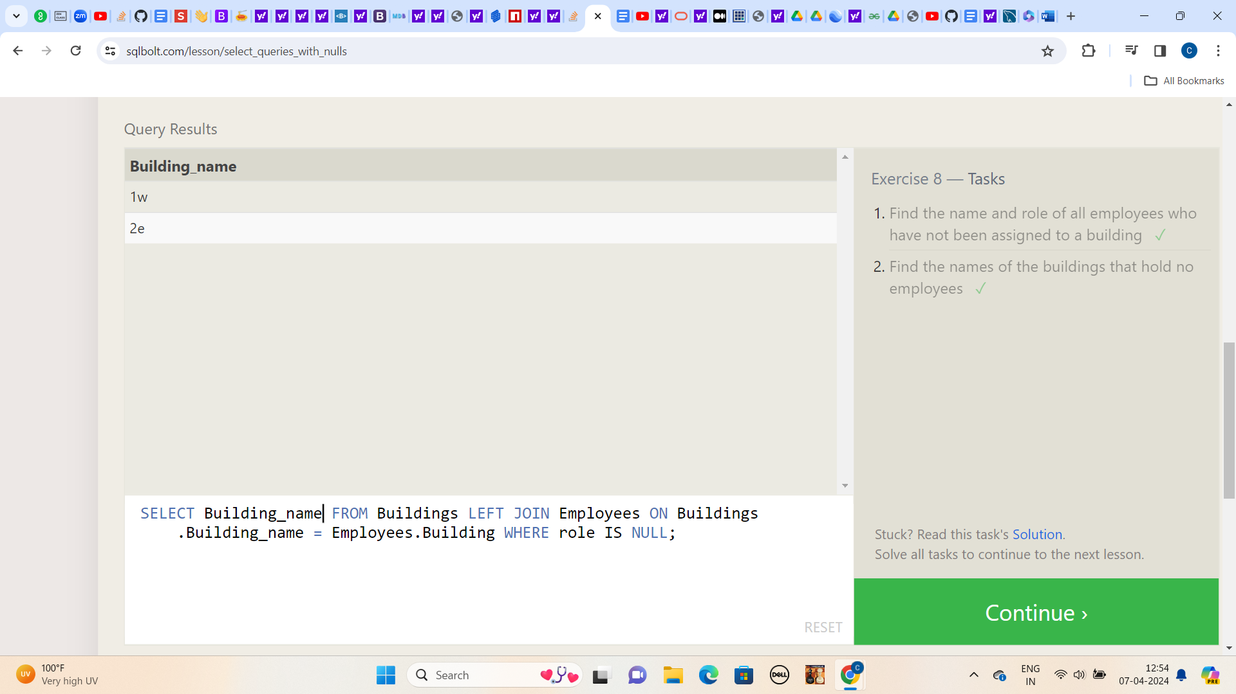

**Lesson:9**

**1.) List all movies and their combined sales in millions of dollars**

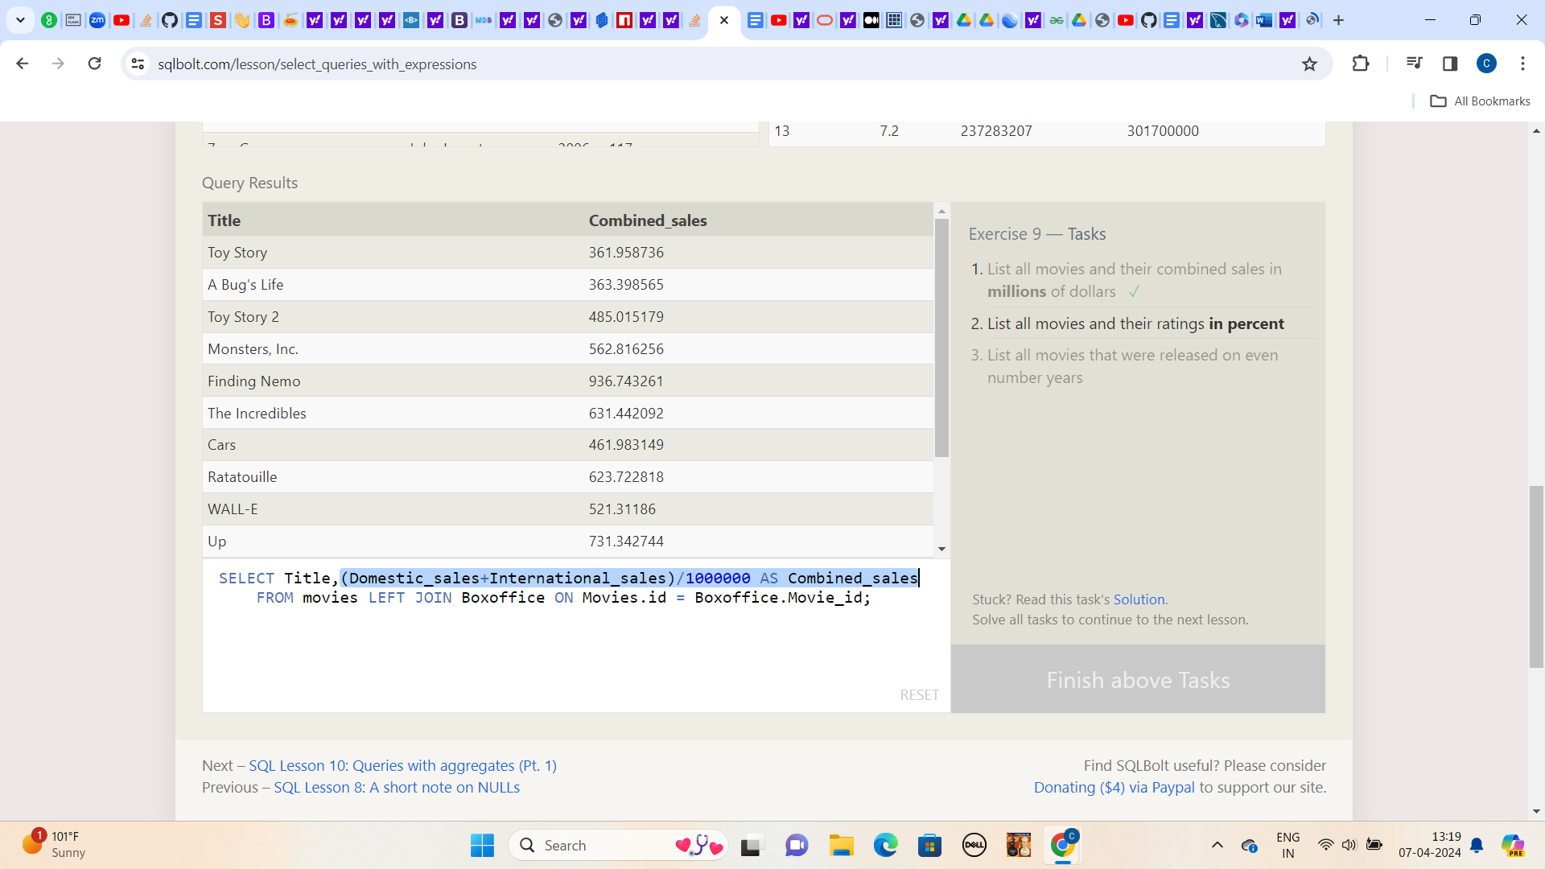

**2.) List all movies and their ratings in percent**

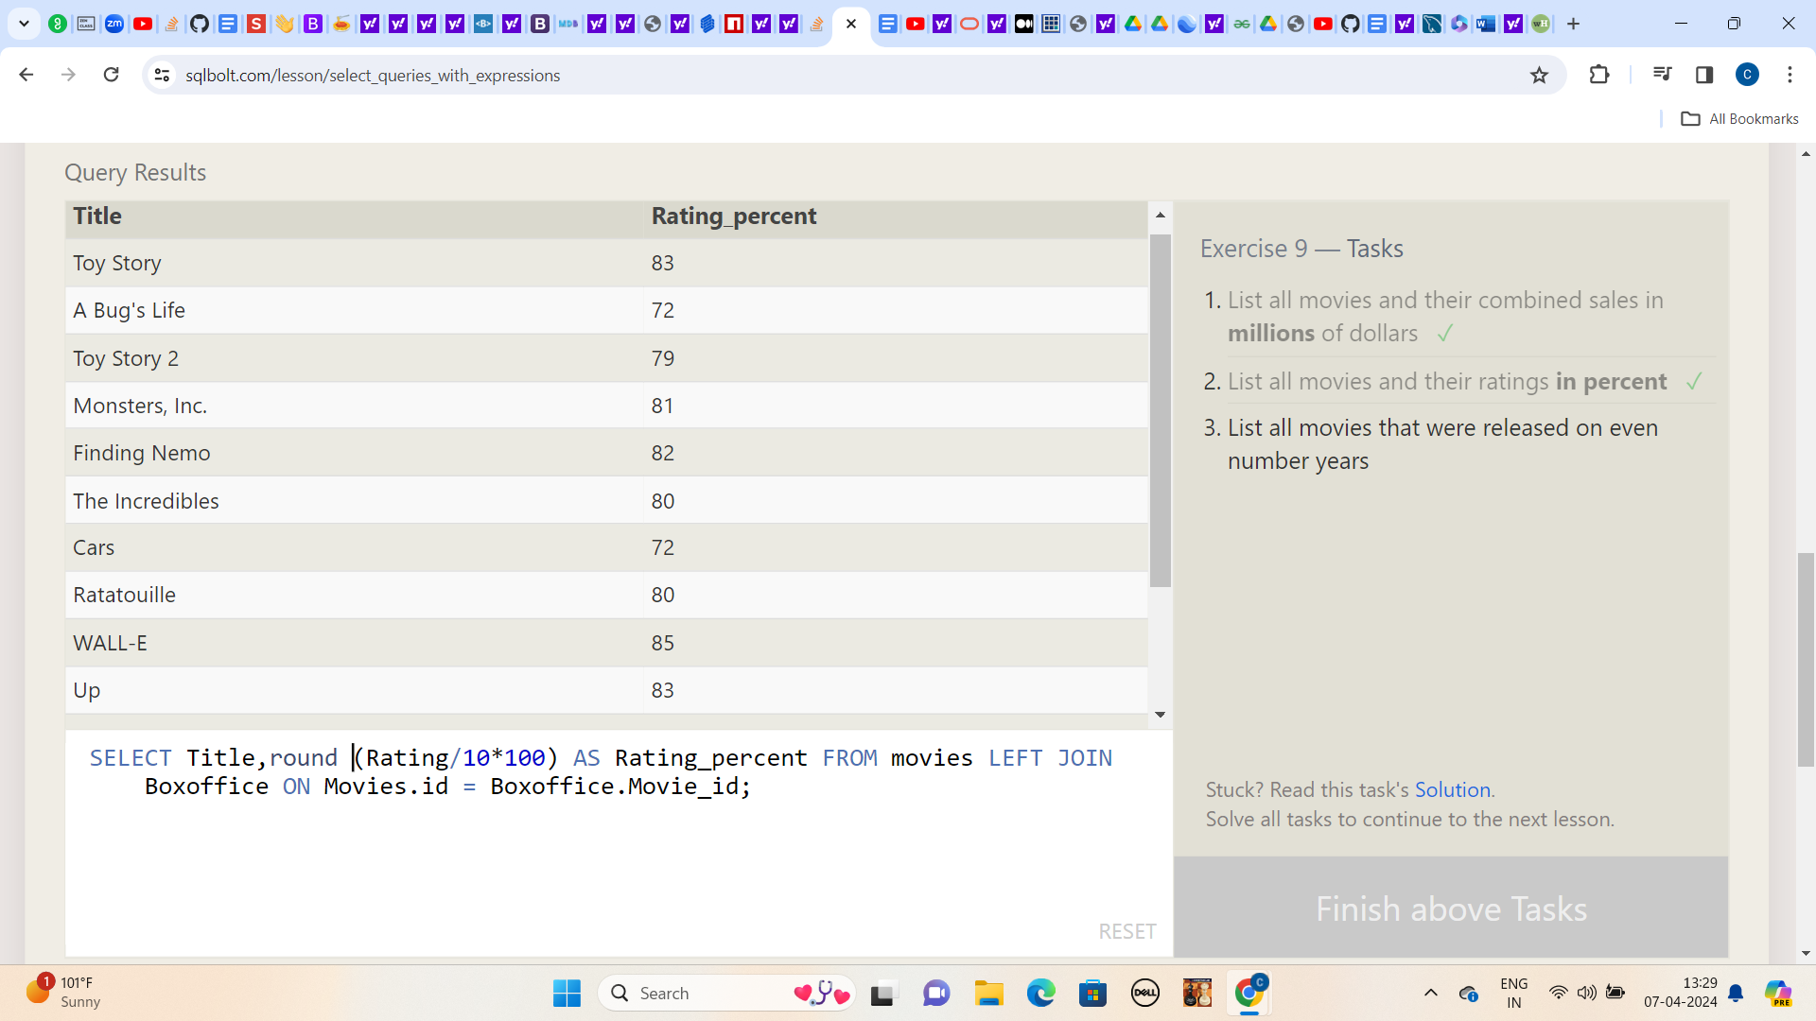

**3.) List all movies that were released on even number years**

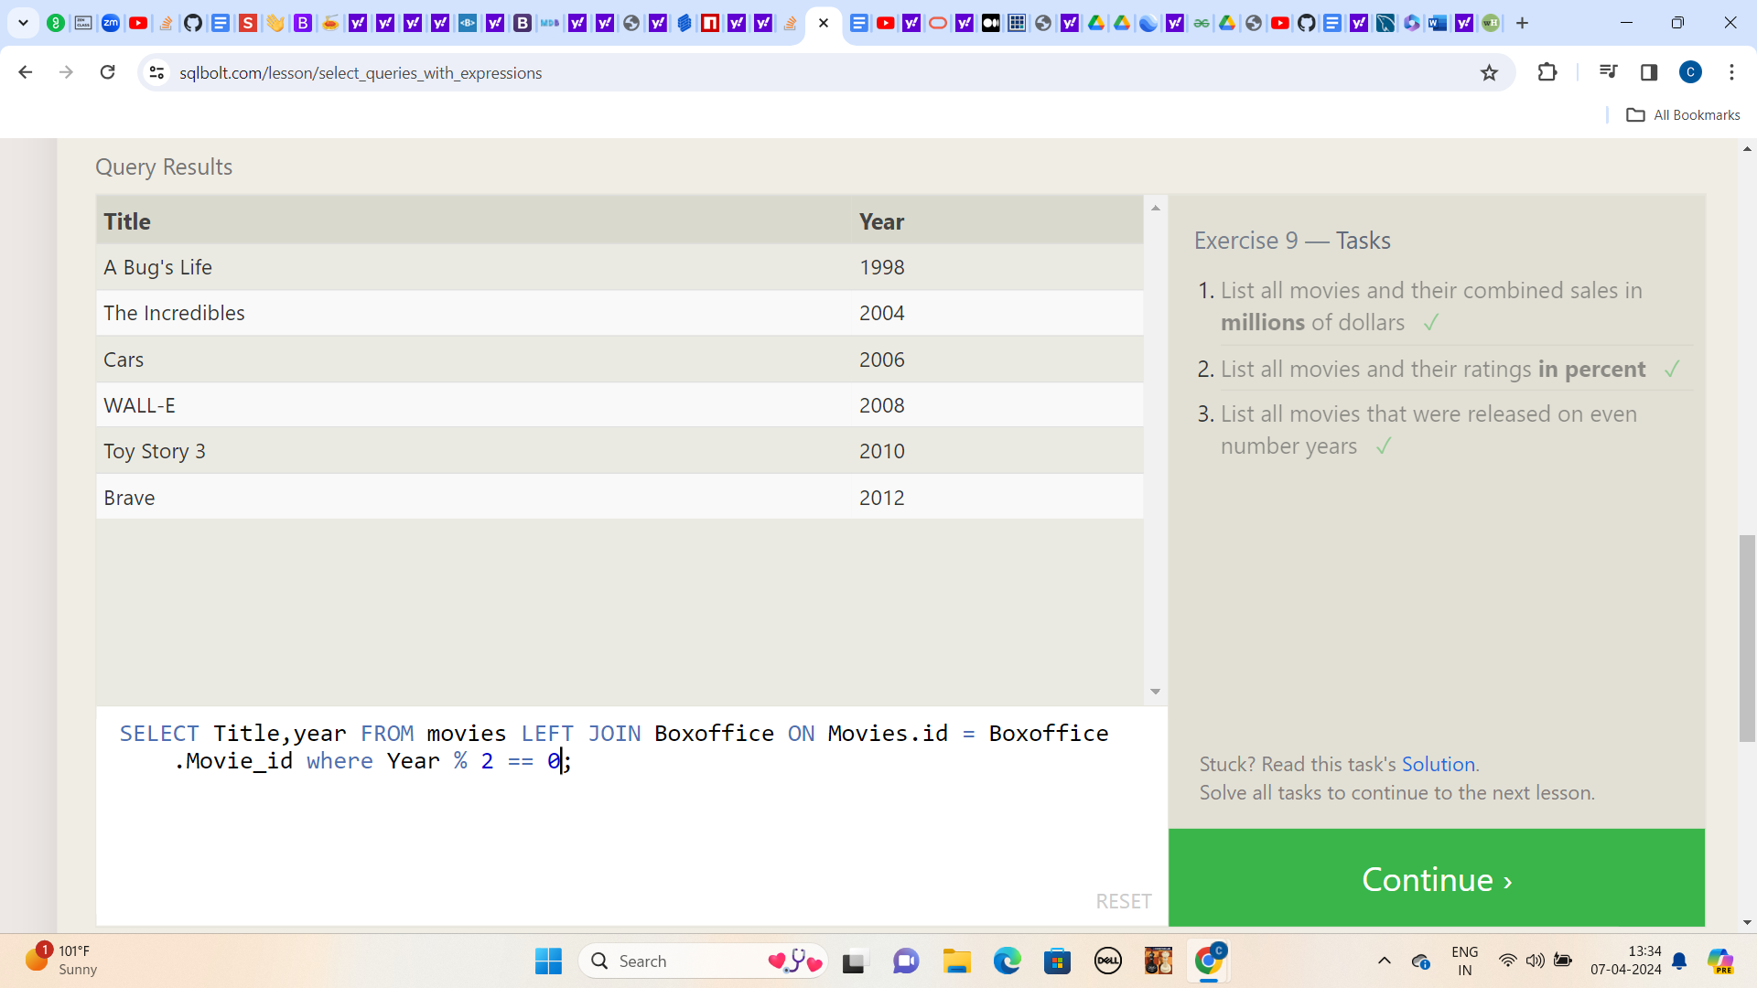

**Lesson:10**

**1.) Find the longest time that an employee has been at the studio**

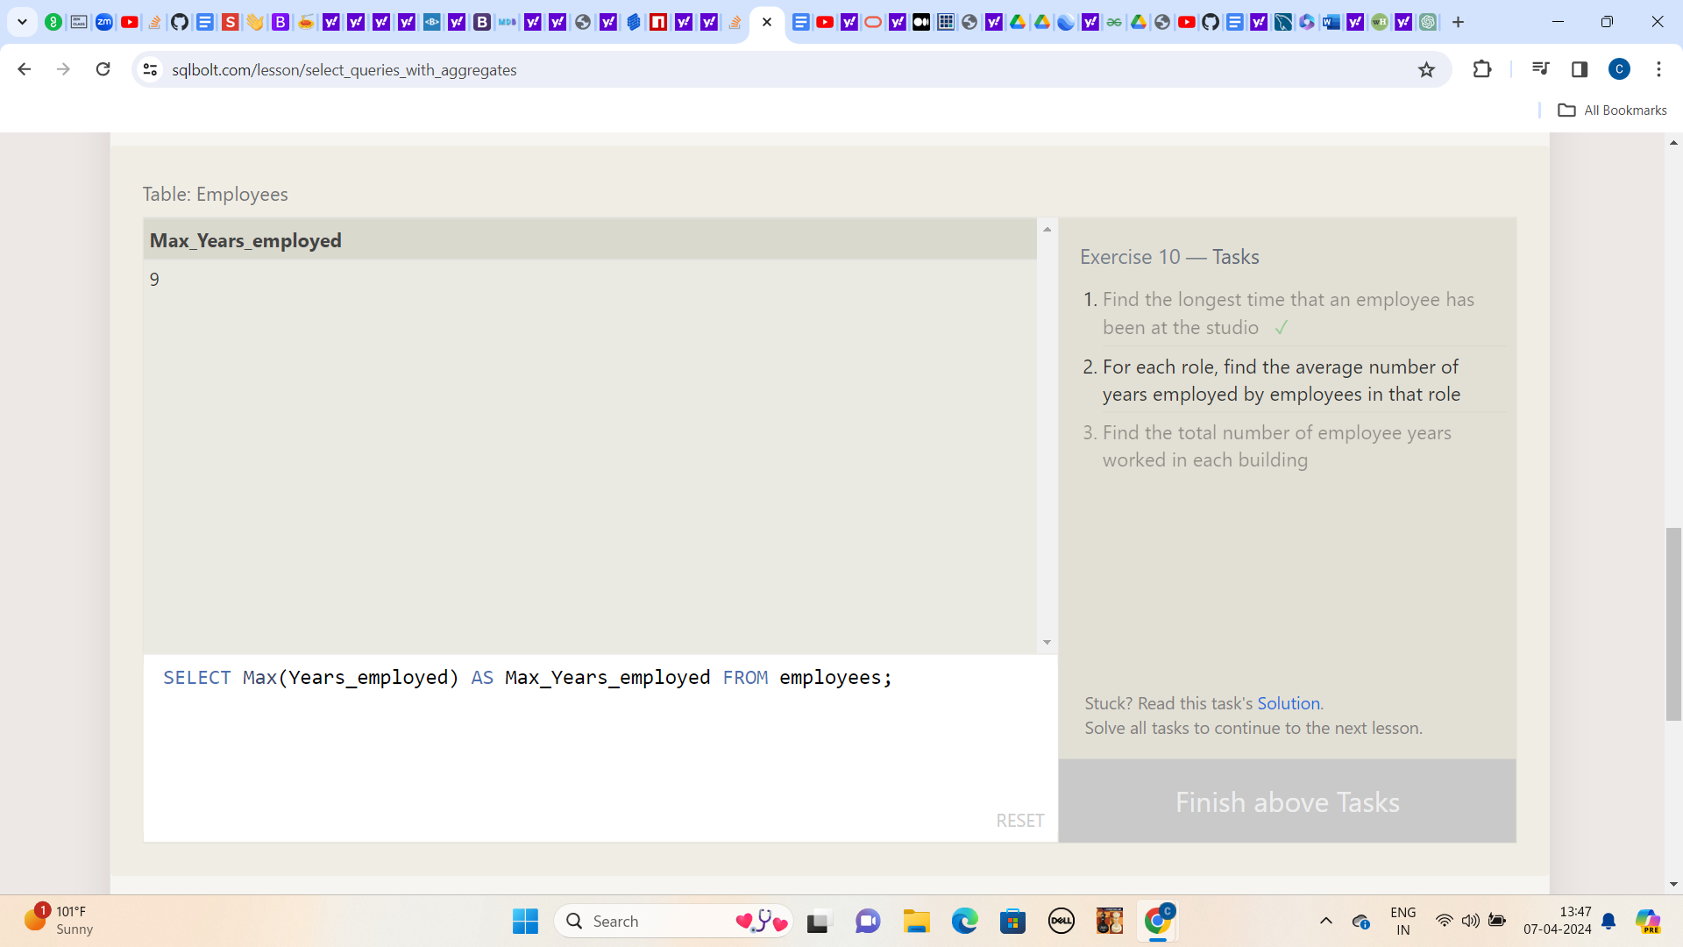

**2.)For each role, find the average number of years employed by employees in that role**

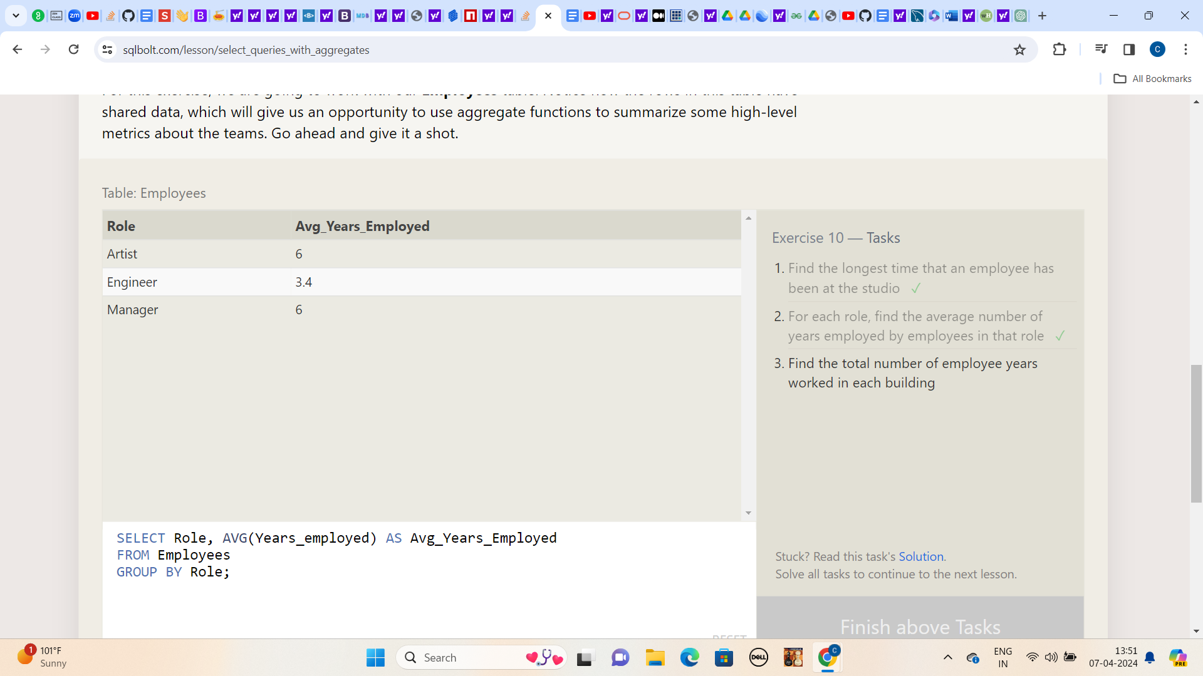

**3.) Find the total number of employee years worked in each building**

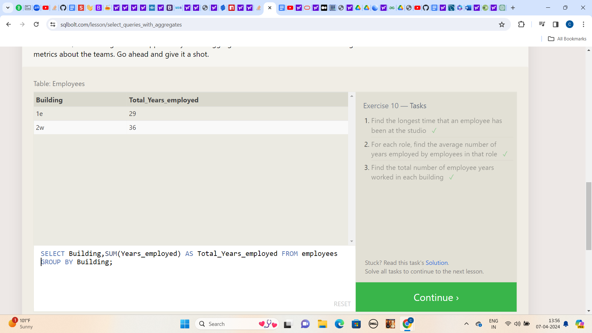

**Lesson:11**

**1.) Find the number of Artists in the studio (without a HAVING clause)**

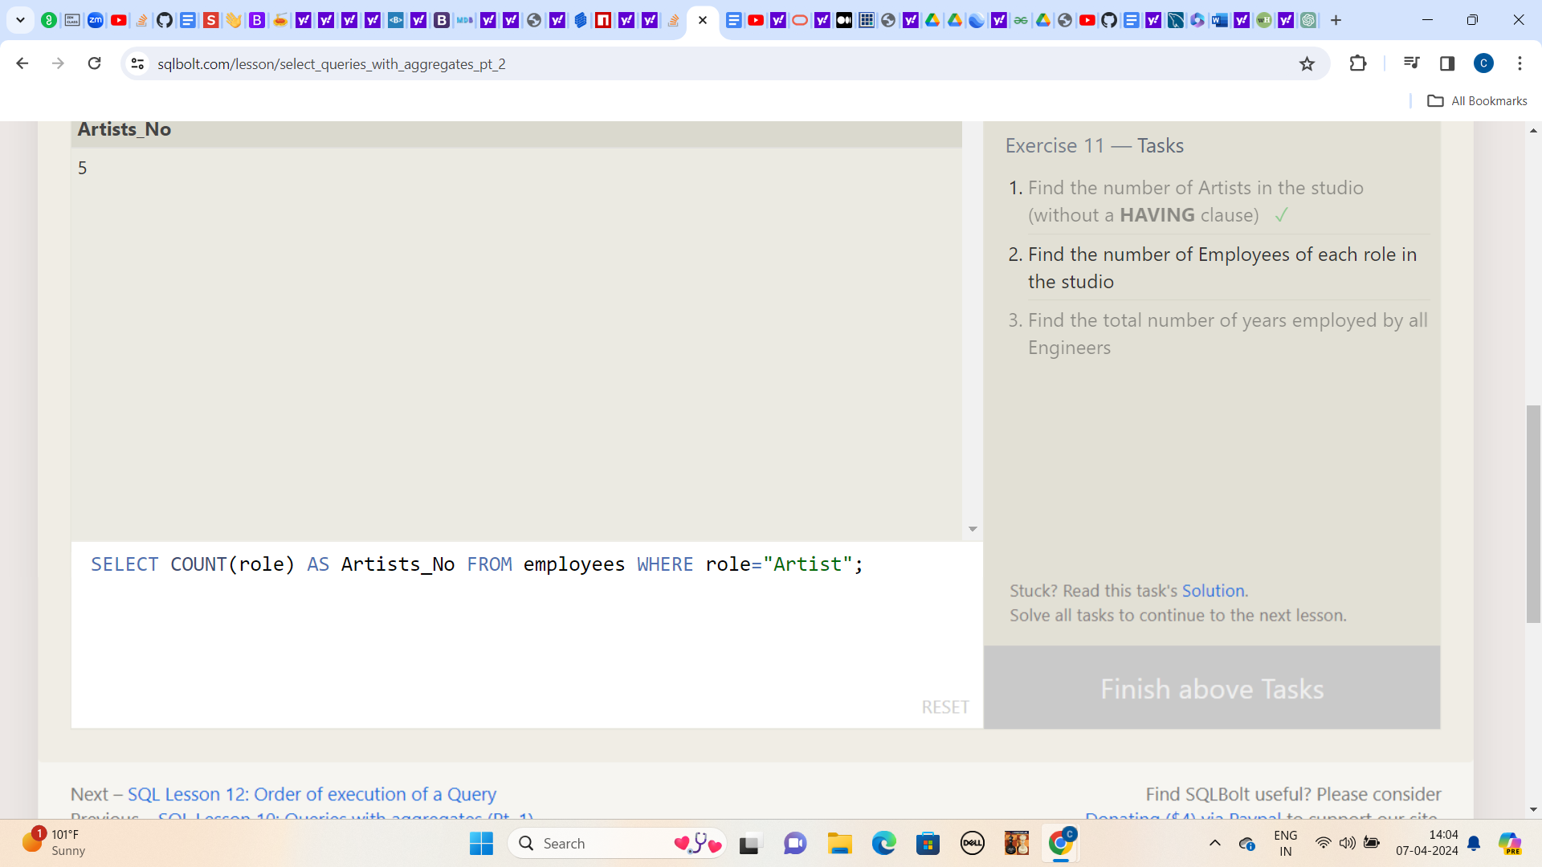

**2.) Find the number of Employees of each role in the studio**

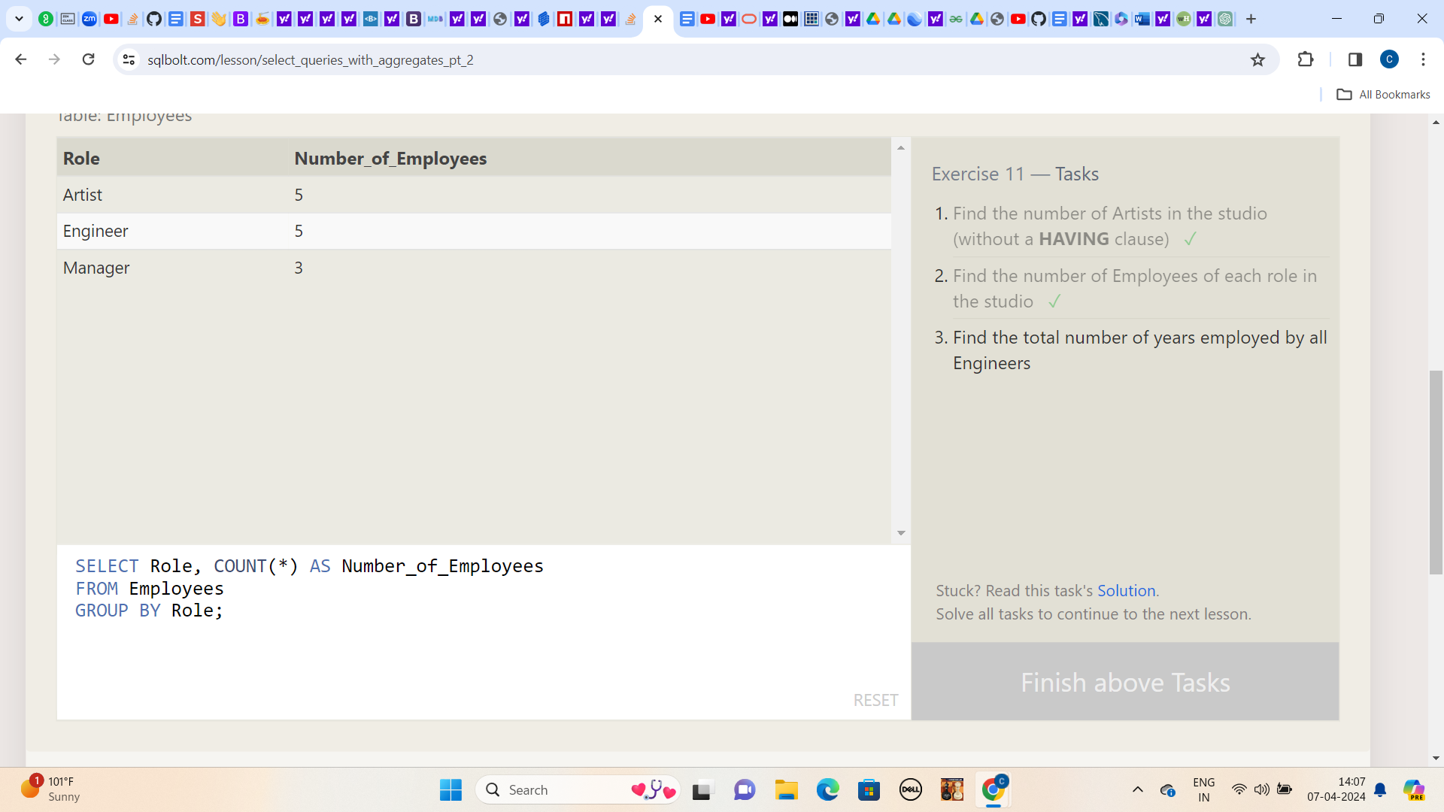

**3.) Find the total number of years employed by all Engineers**

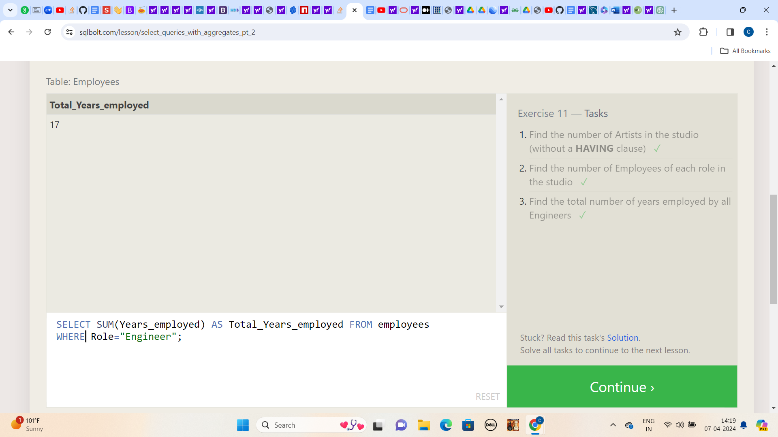

**Lesson:12**

**1.) Find the number of movies each director has directed**

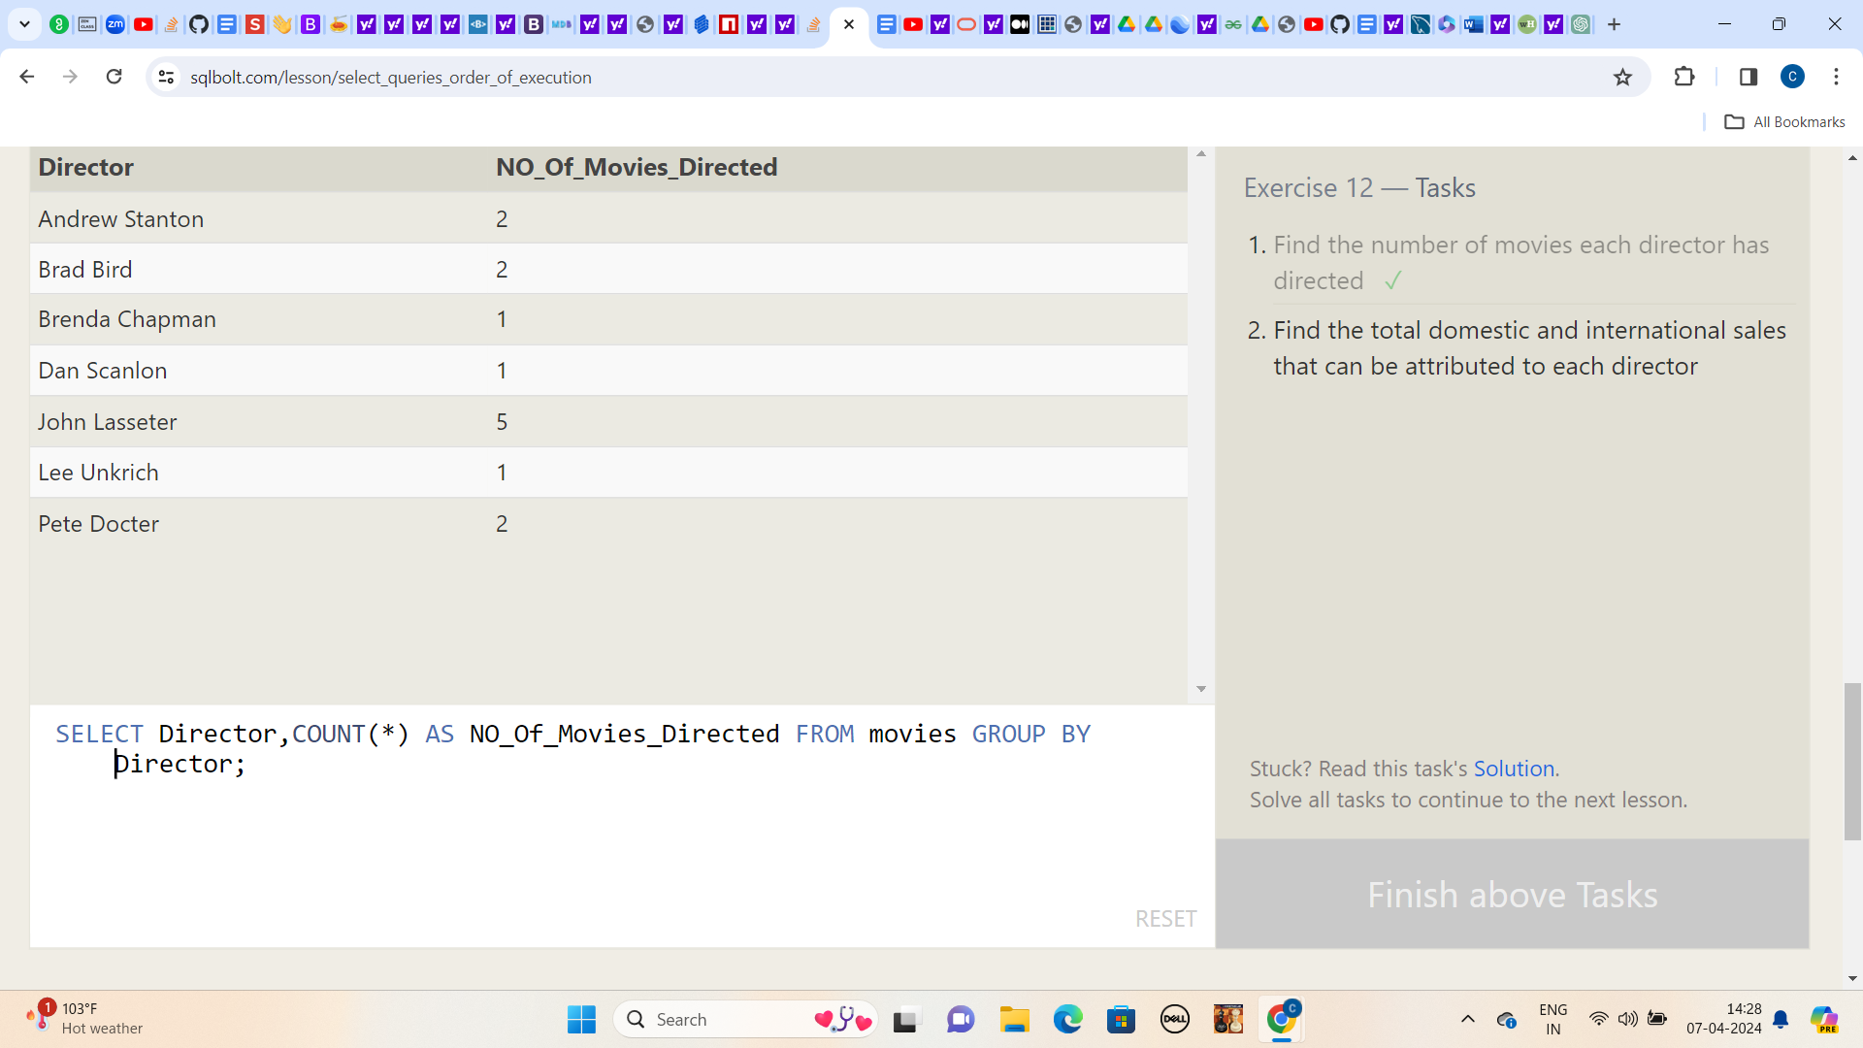

**2.) Find the total domestic and international sales that can be attributed to each director**

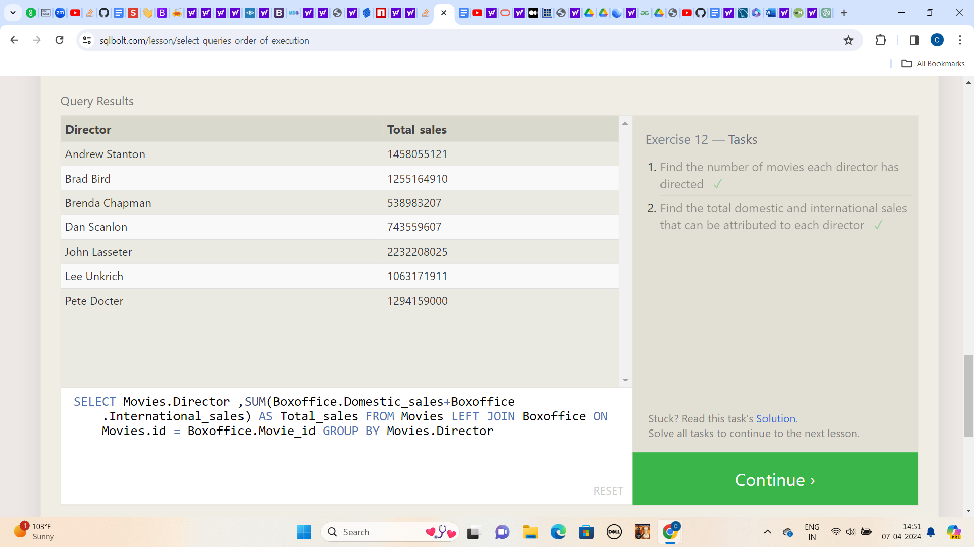

**Lesson:13**

**1.) Add the studio's new production, Toy Story 4 to the list of movies (you can use any director)**

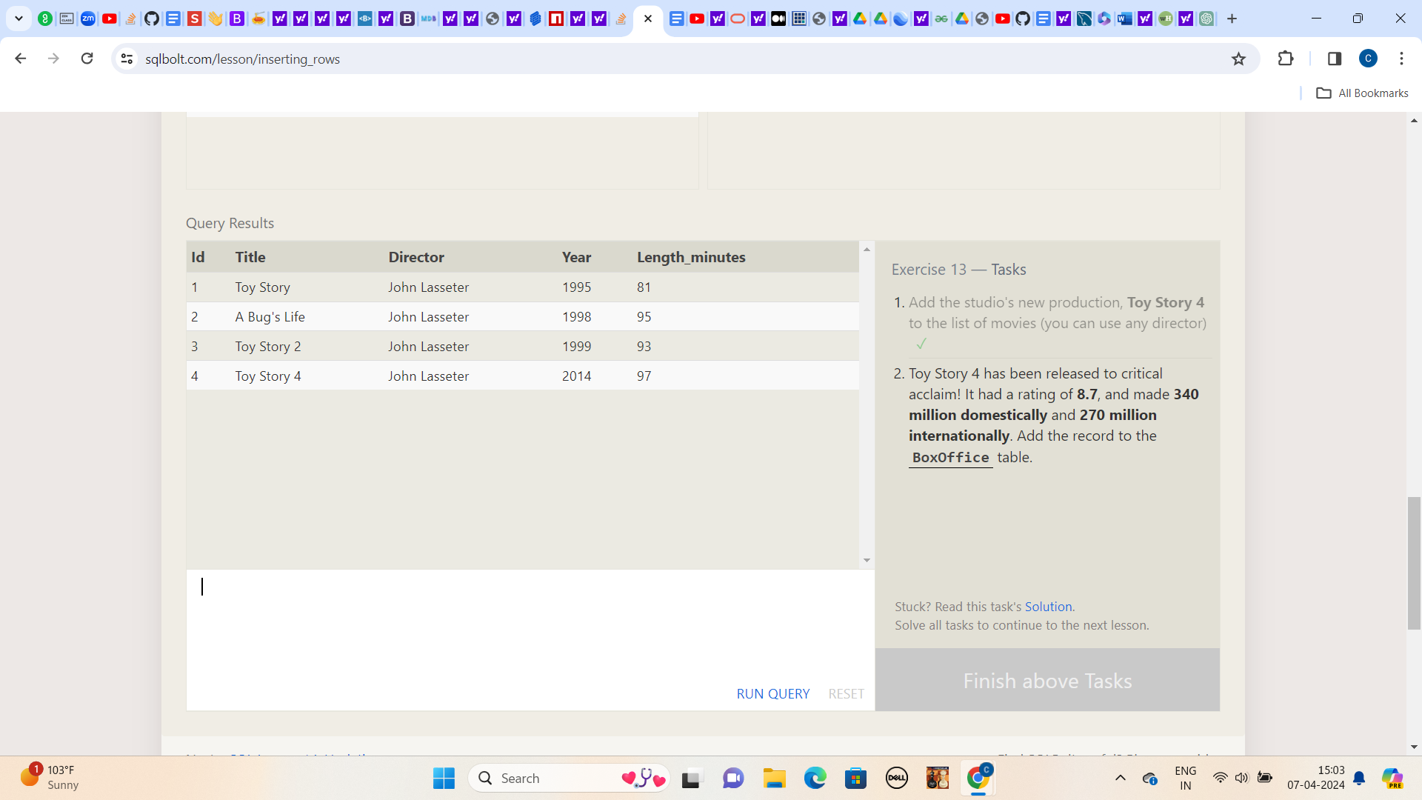

**2.) Toy Story 4 has been released to critical acclaim! It had a rating of 8.7, and made 340 million domestically and 270 million internationally. Add the record to the BoxOffice table.**

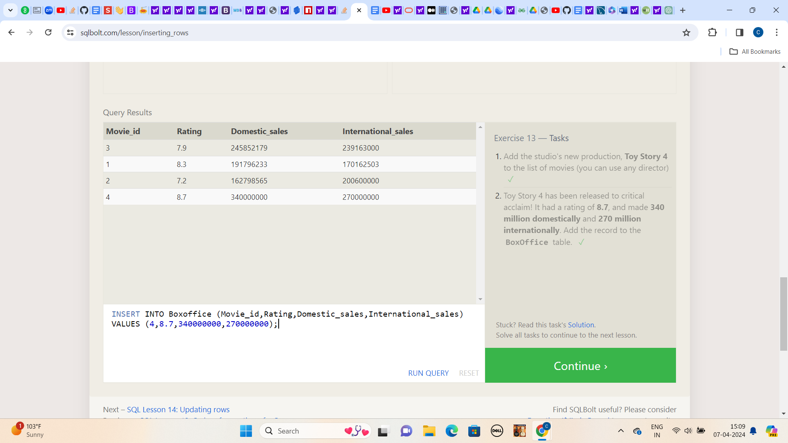

**Lesson:14**

**1.) The director for A Bug's Life is incorrect, it was actually directed by John Lasseter**

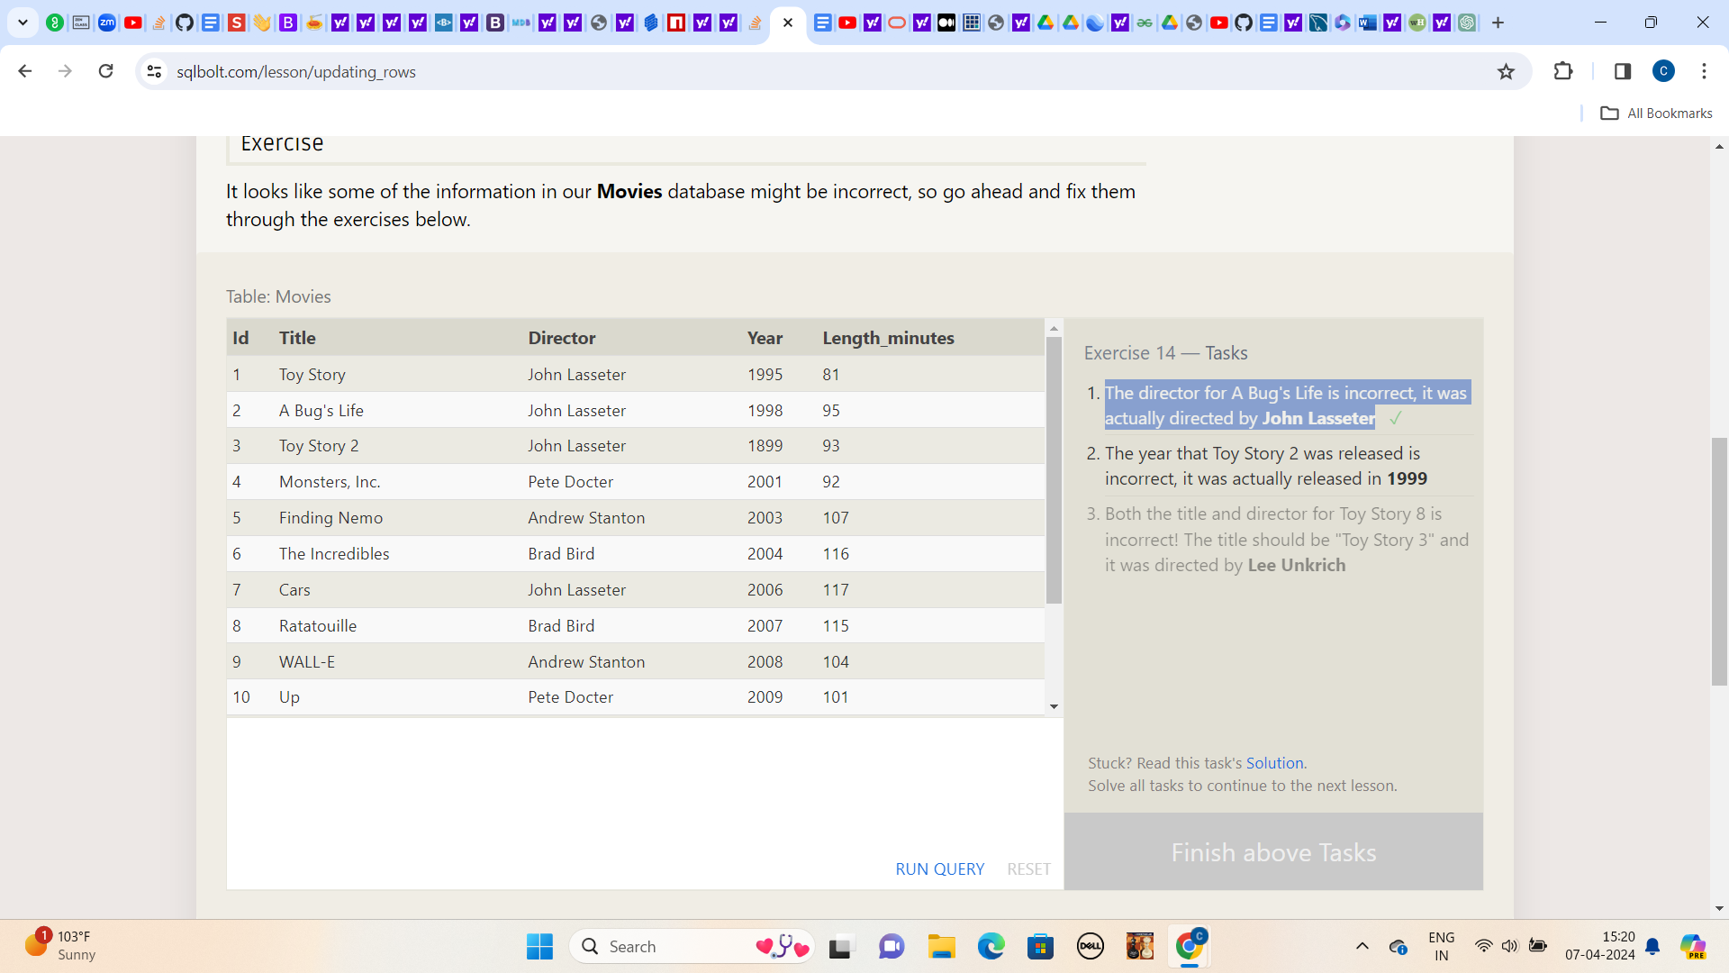

**2.) The year that Toy Story 2 was released is incorrect, it was actually released in 1999**

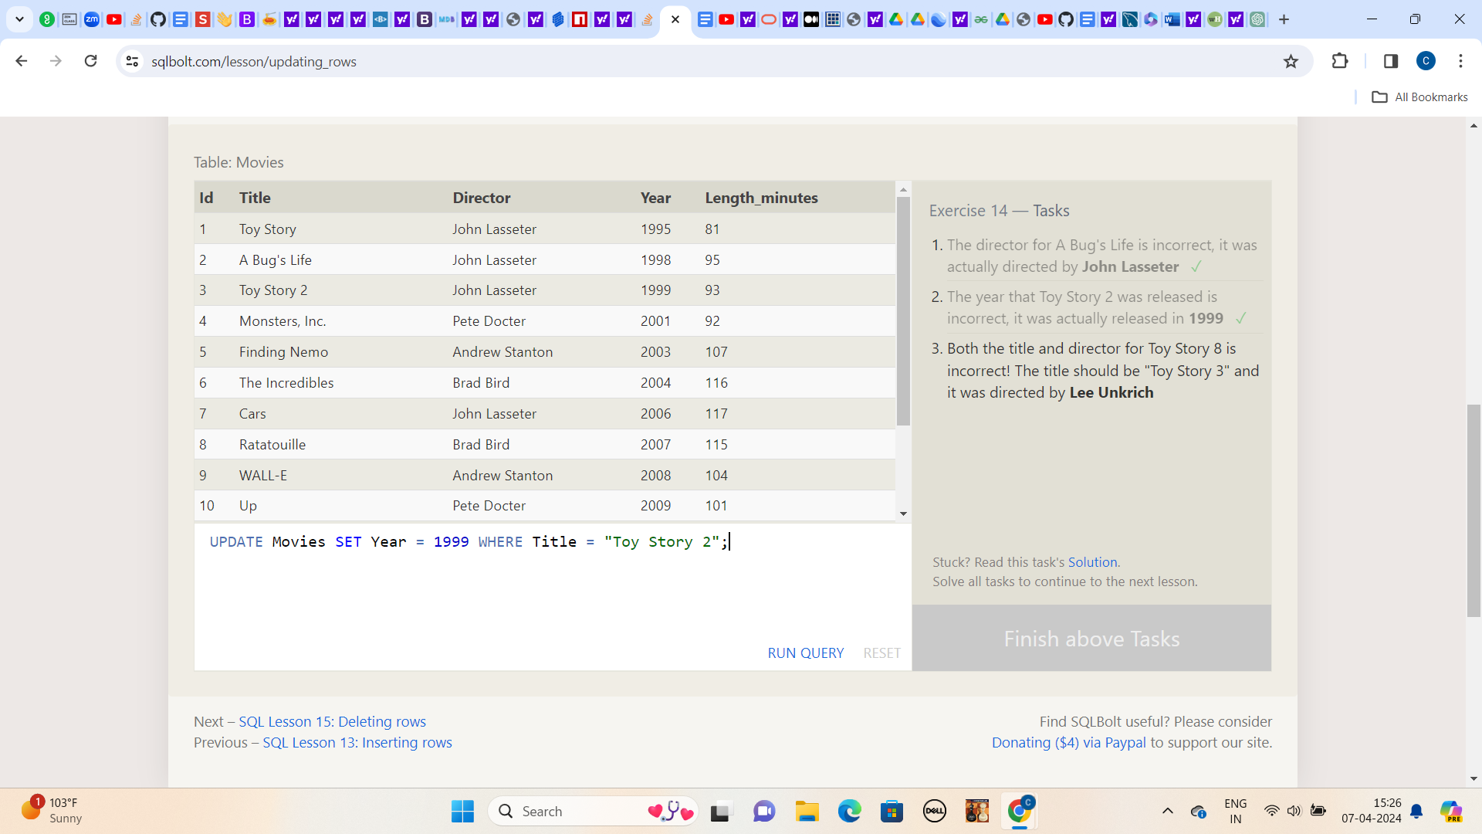

**3.) Both the title and director for Toy Story 8 is incorrect! The title should be "Toy Story 3" and it was directed by Lee Unkrich**

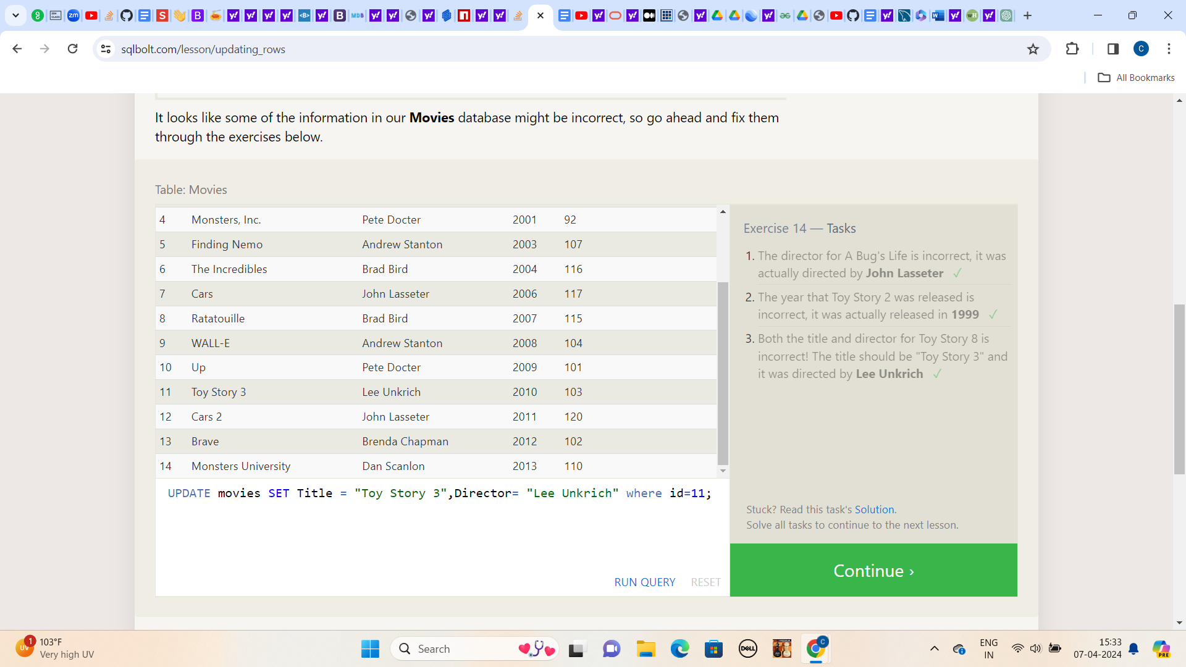

**Lesson:15**

**1.) This database is getting too big, lets remove all movies that were released before 2005.**

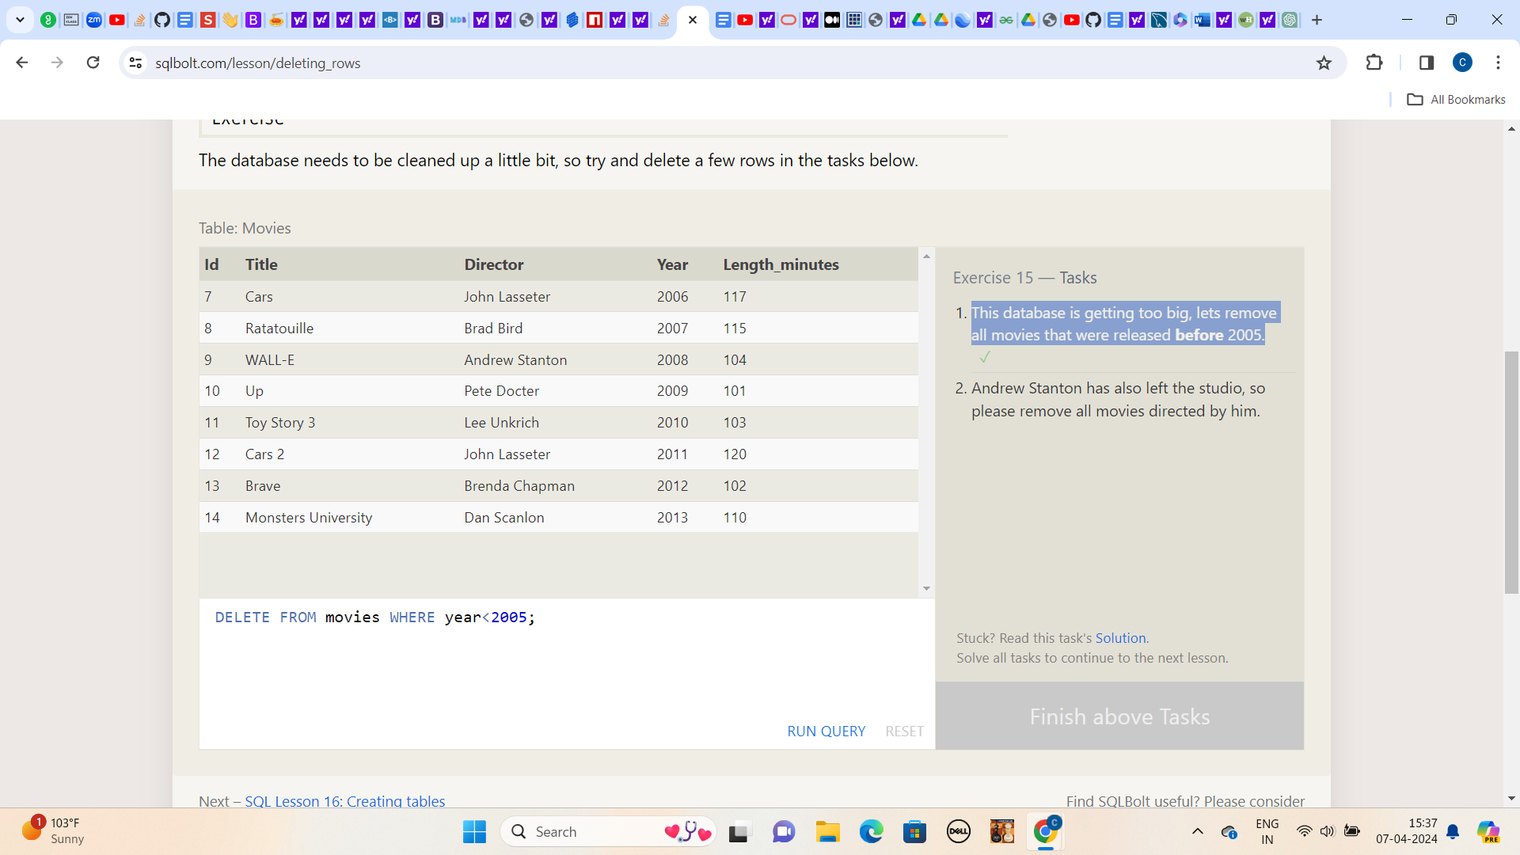

**2.) Andrew Stanton has also left the studio, so please remove all movies directed by him**

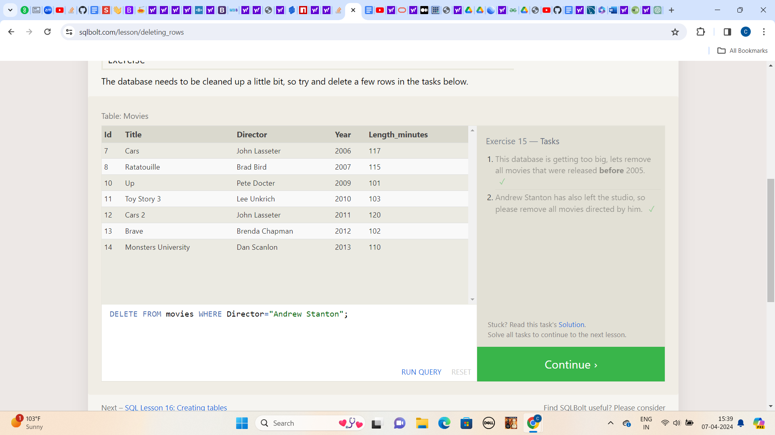

**Lesson:16**

1. **Create a new table named Database with the following columns:  
     
   – Name A string (text) describing the name of the database  
   – Version A number (floating point) of the latest version of this database  
   – Download_count An integer count of the number of times this database was downloaded  
     
   This table has no constraints.**

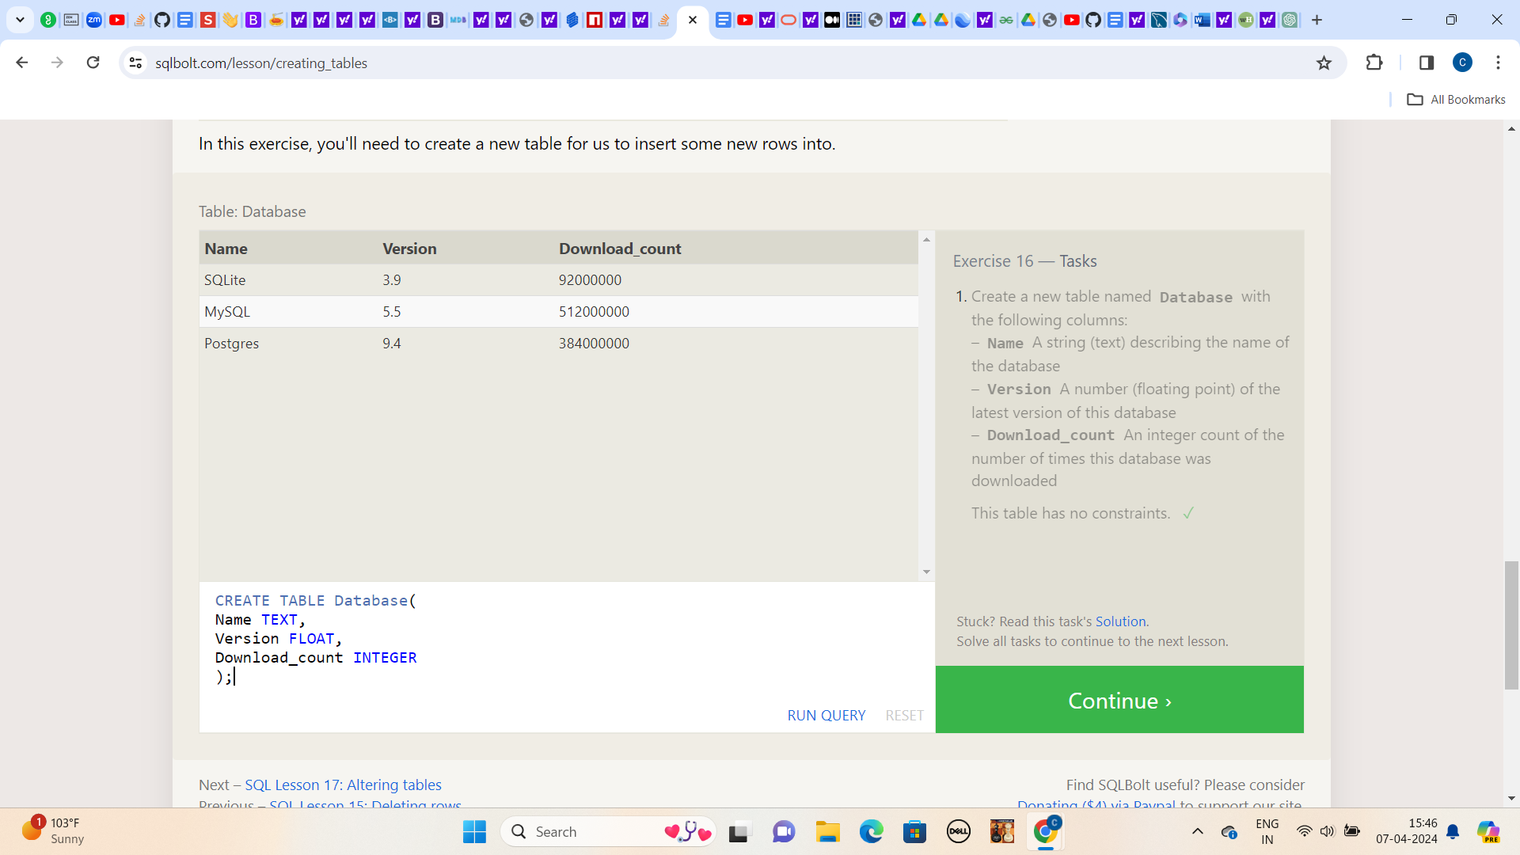

**Lesson:17**

**1.) Add a column named Aspect_ratio with a FLOAT data type to store the aspect-ratio each movie was released in.**

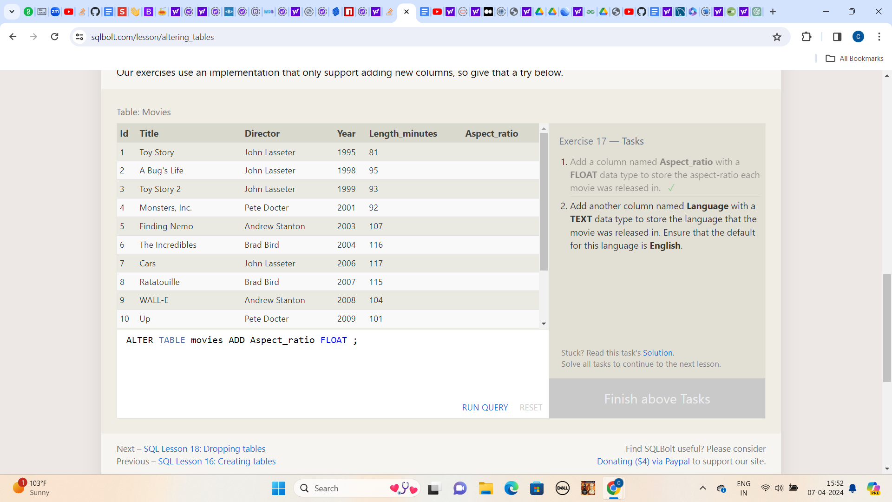

**2.) Add another column named Language with a TEXT data type to store the language that the movie was released in. Ensure that the default for this language is English.**

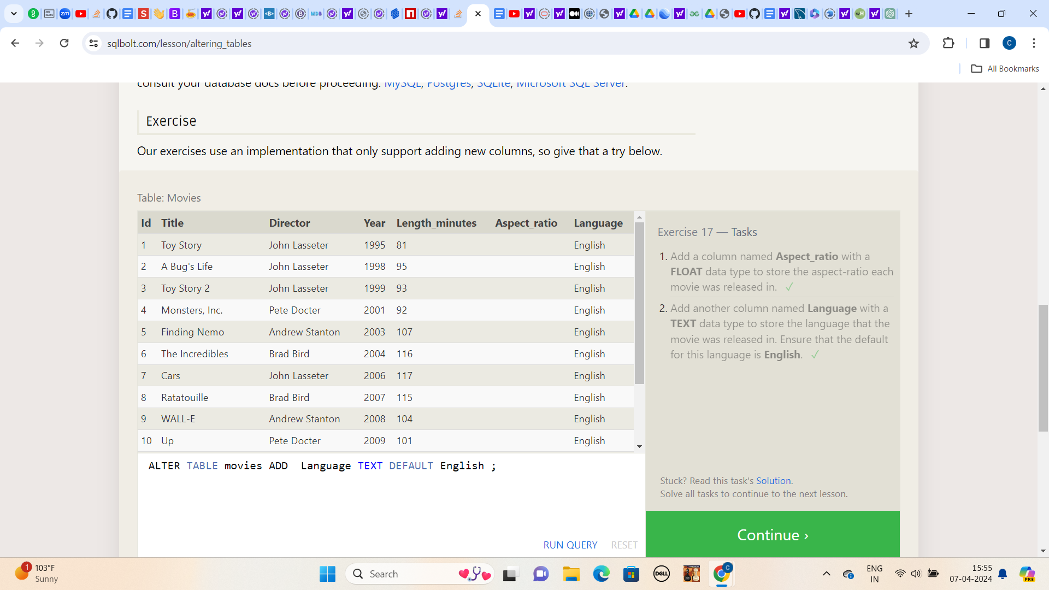

**Lesson:18**

**1.) We've sadly reached the end of our lessons, lets clean up by removing the Movies table**

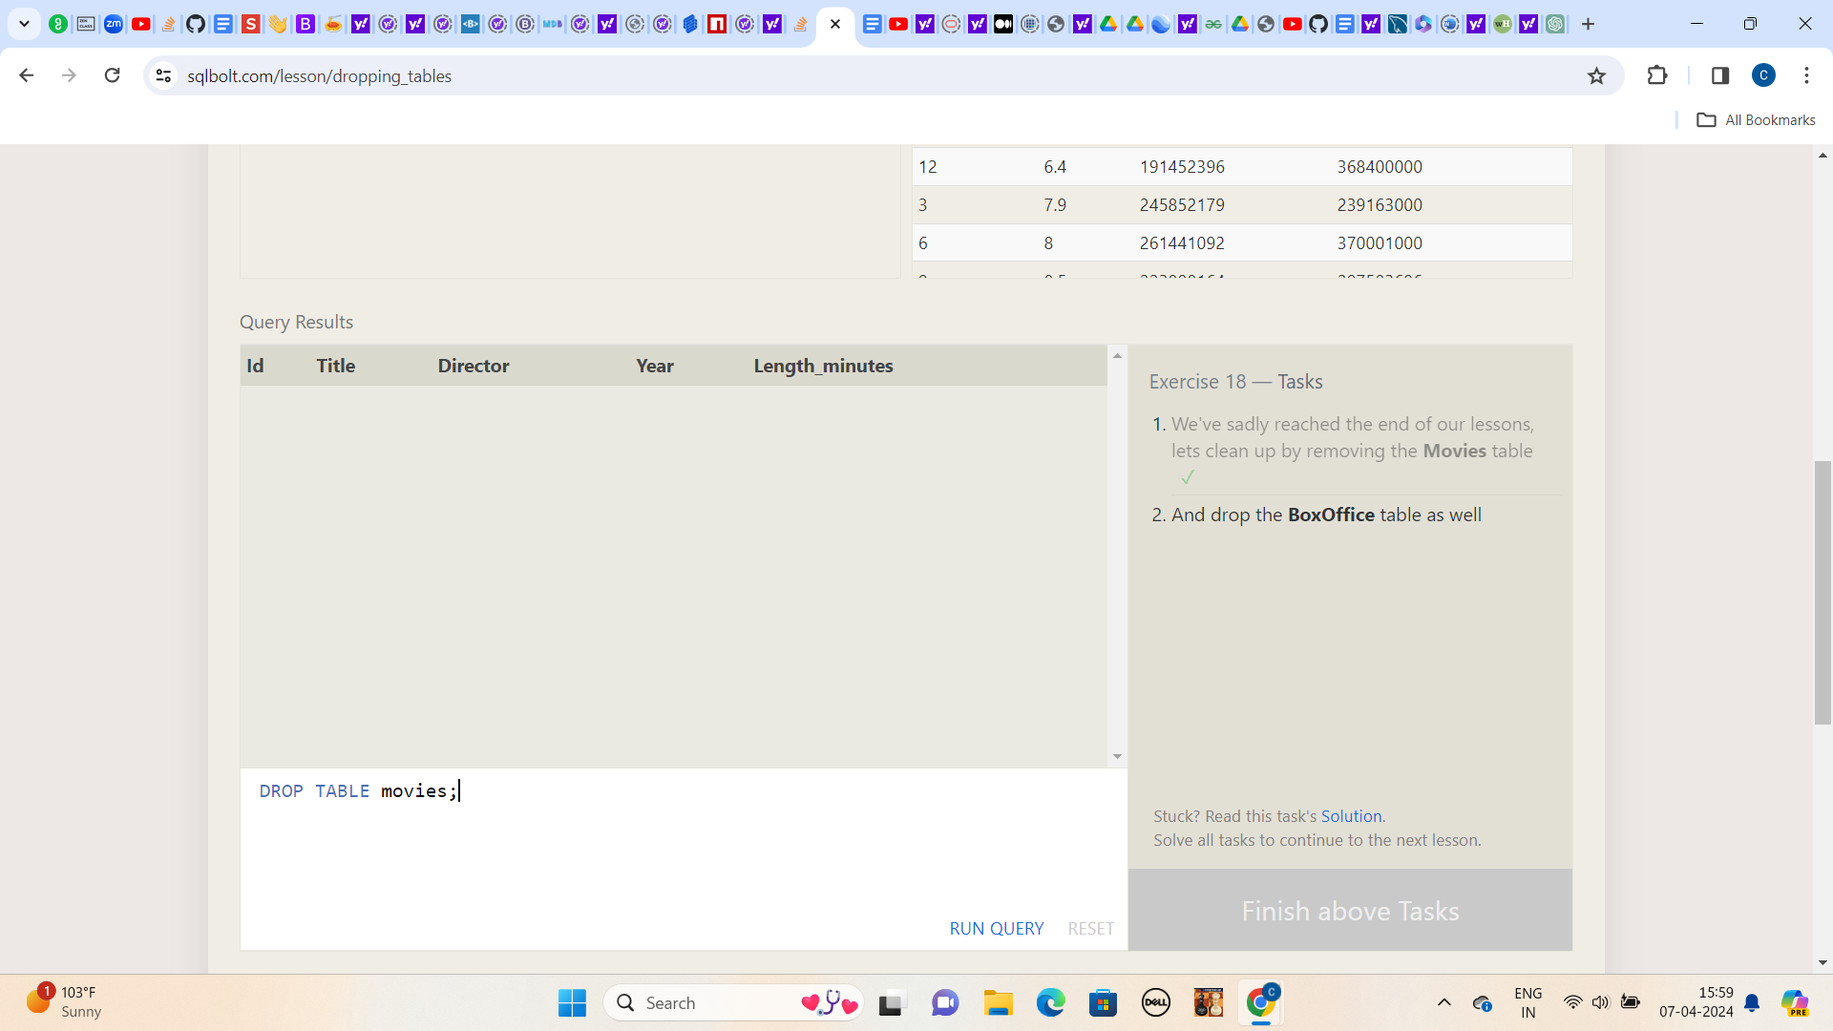

**2.) And drop the BoxOffice table as well**

